BOOKING WITH CHRISTOPHERSON BUSINESS TRAVEL
VERY IMPORTANT!!
CHECK YOUR PROFILE TO ENSURE YOU ARE LISTED IN THE CORRECT AGENCY
Go to cbtravel.com and click on Air Portal Login
Login to Air Portal using your state authorized email address and your password.
On the upper right-hand side in Air Portal click on your name then View Travel Profile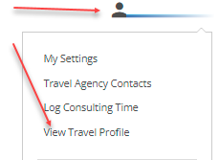 Under Company Information you will find your Agency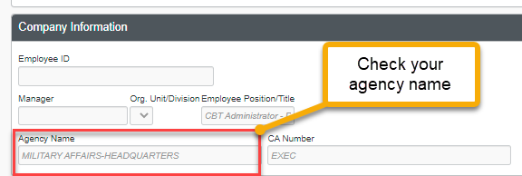

IF THIS INFORMATION IS NOT CORRECT IT WILL DELAY YOUR TICKET PROCESS AND POSSIBLY CAUSE THE TICKET PRICE TO INCREASE.
REACH OUT TO ONLINESUPPORT@CBTRAVEL.COM TO UPDATE WITH THE CORRECT AGENCY NAME.

