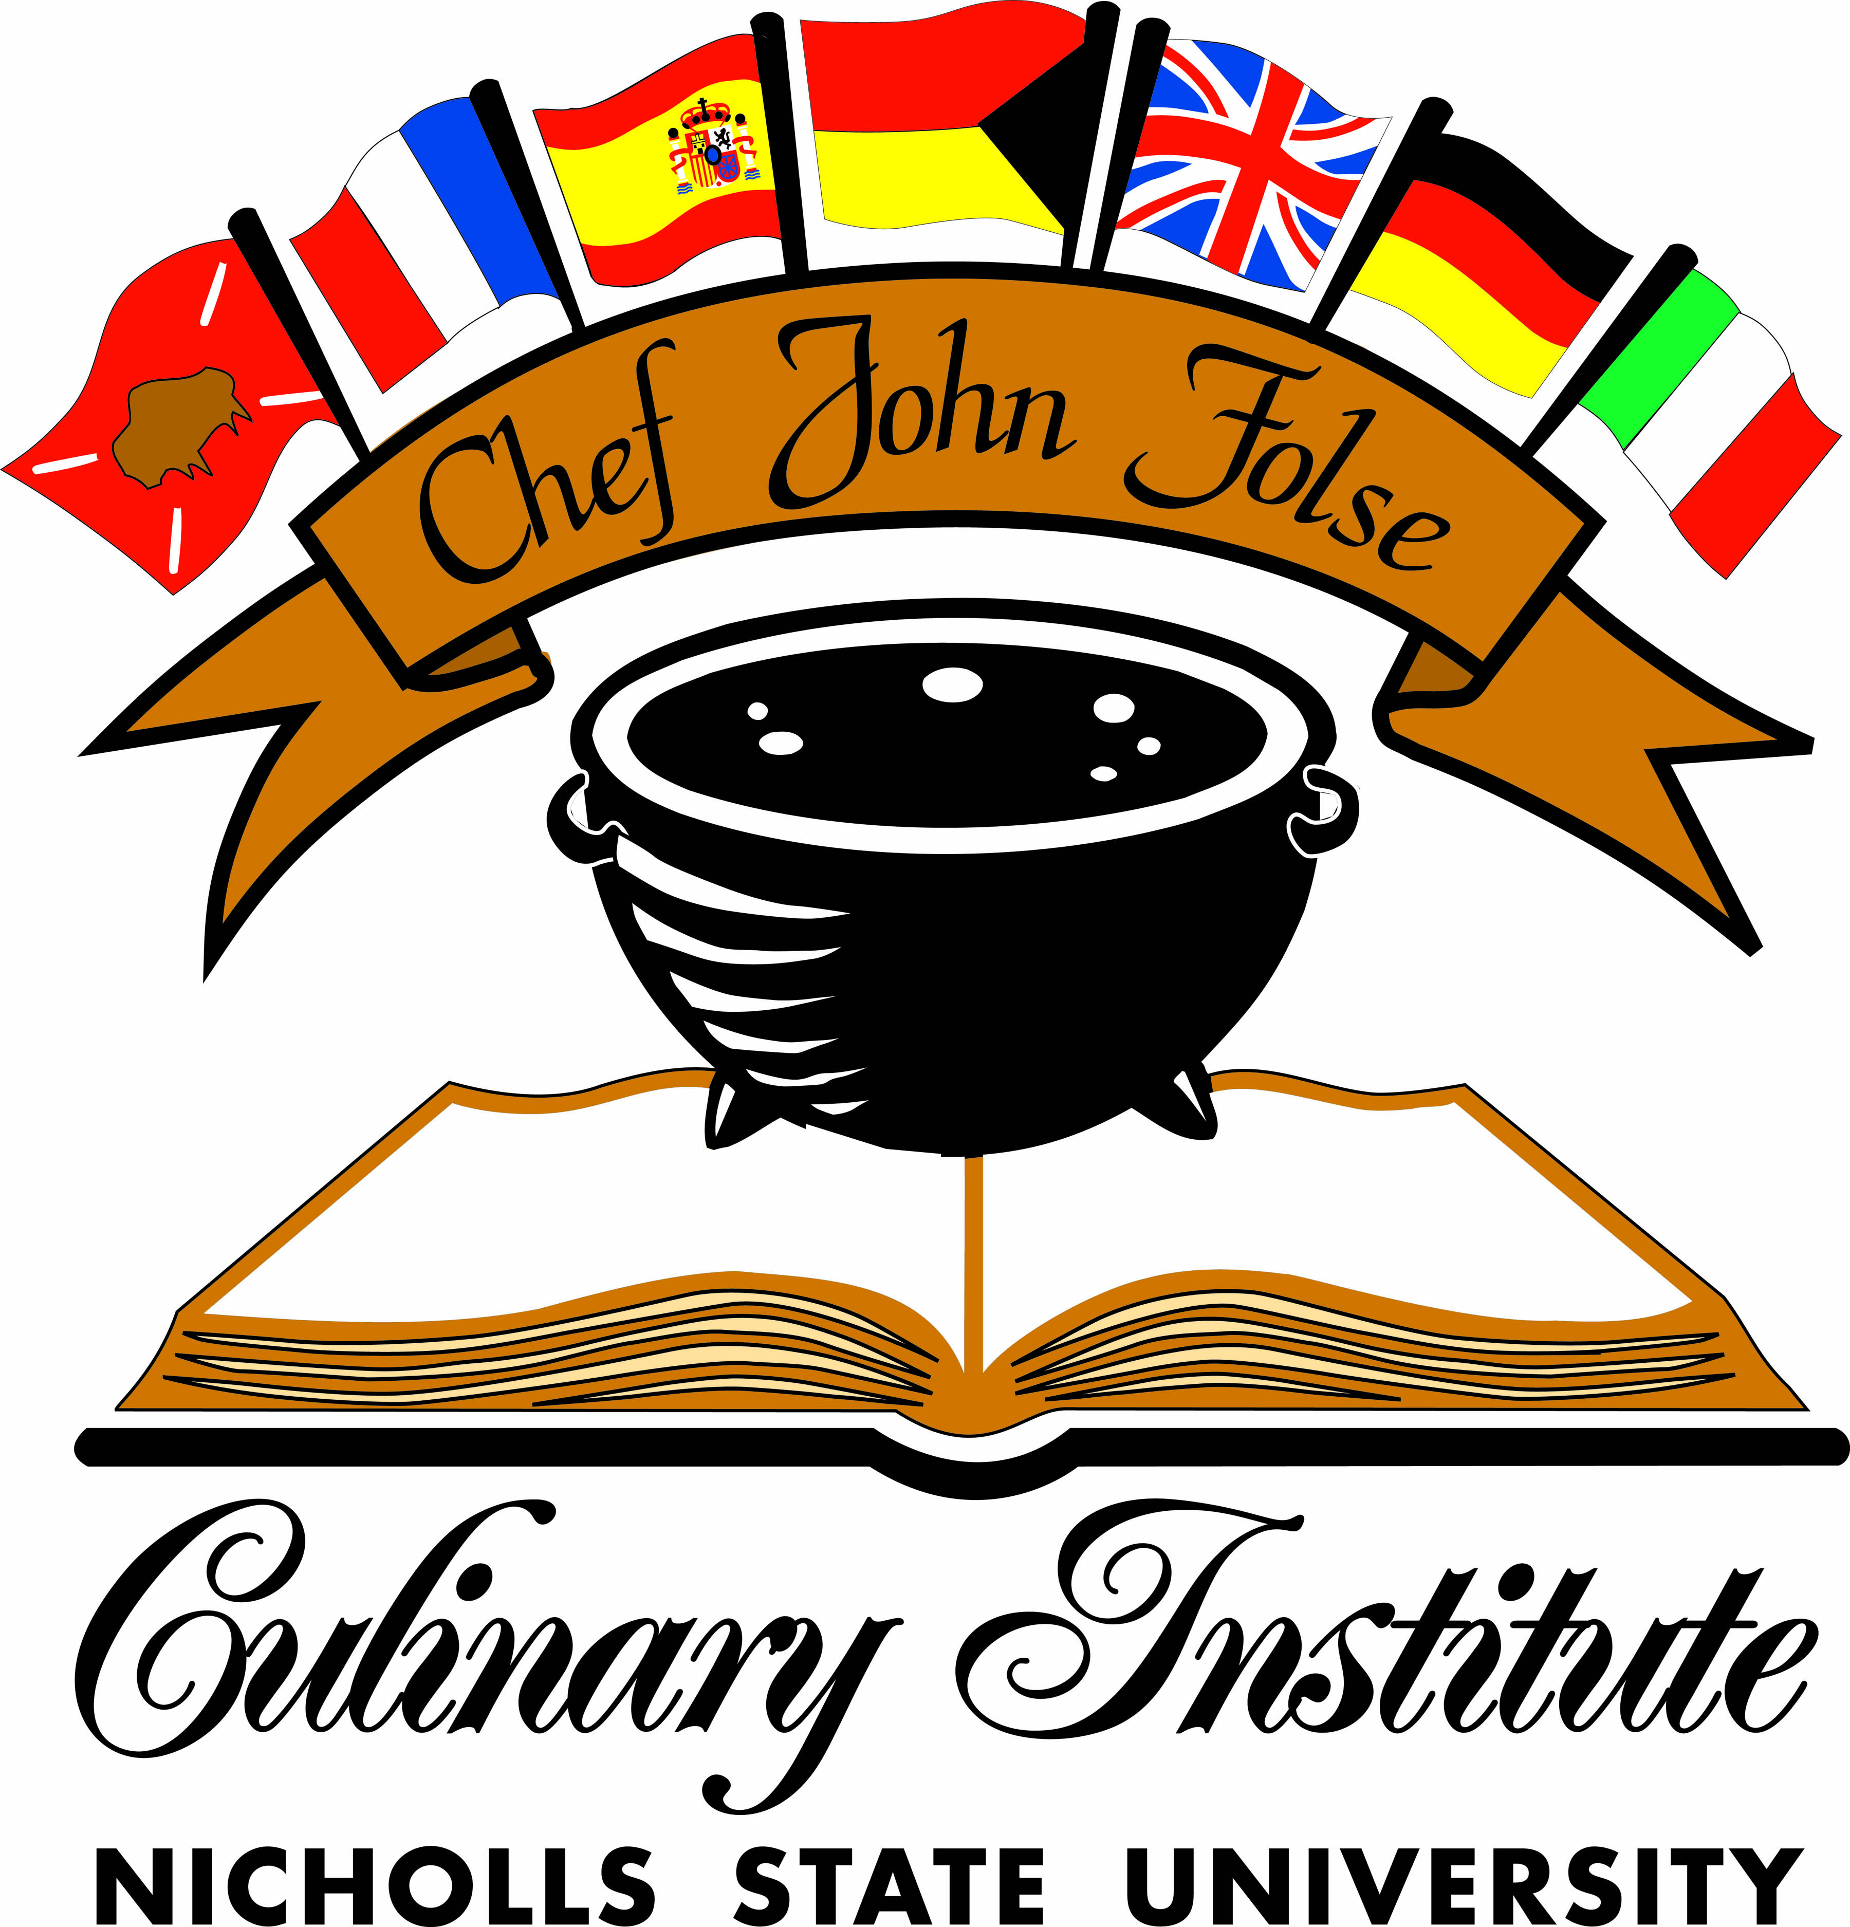John Folse Culinary Institute
Recipe Name: Boudin Boulettes
Class and Instructor: CULA 315, Chef Jana
Source: Chef Jana - Boudin, https://www.allrecipes.com/recipe/240805/boudin-balls/, https://minimalistbaker.com/how-to-cook-white-rice/
Yield: 42, 3 oz servings
5lbs Cushion Meat  1.25lbs pork livers  0.75lbs fatback | Cut meat into small cubes to help the blanching process.  Blanch Cushion meat, Fat back and liver for approx. 5 minutes
0.75lbs bell pepper  1.75lbs yellow onion  0.25lbs garlic  0.5 Tbsp celery seed  0.5 tbsp msg  2 tbsp garlic powder  1 tbsp black pepper  0.75 tbsp cayenne  0.5 tbsp white pepper  3.25 tbsp salt | Puree remaining ingredients and combine them with cushion meat, fat back, and pork liver
 | Plastic and foil wrap hotel pan and cook at 300F for 3 hrs
1 qt white rice, dry  ½ gallon water | Add rice and water to a pot and bring to a boil over high heat.  Once boiling, turn heat down to low to simmer. Simmer for approx. 15 minutes, until rice is tender
1 cup parsley, chopped  2 cups green onions, chopped | Grind all through meat grinder  Paddle Mix with rice, green onions, parsley and cooked rice  Scoop with black (1oz) scoop and form into balls
3 cup AP flour  3 pinches cayenne  Salt and pepper to taste  3 cups dry breadcrumb  6 large eggs, beaten | Whisk together flour and seasonings  Set up 3 stage dredging station with flour mix, eggs, and breadcrumbs  Dredge through 3 stage breading station, and let sit overnight till service
For Service: Heat oil to 350F and fry until golden brown.
Assemble plating with brussel sprout salad in the middle, 3 dollops of horseradish remoulade on the plate, boudin balls on the dollops, with remoulade on top of each ball, and a petite shamrock microgreen

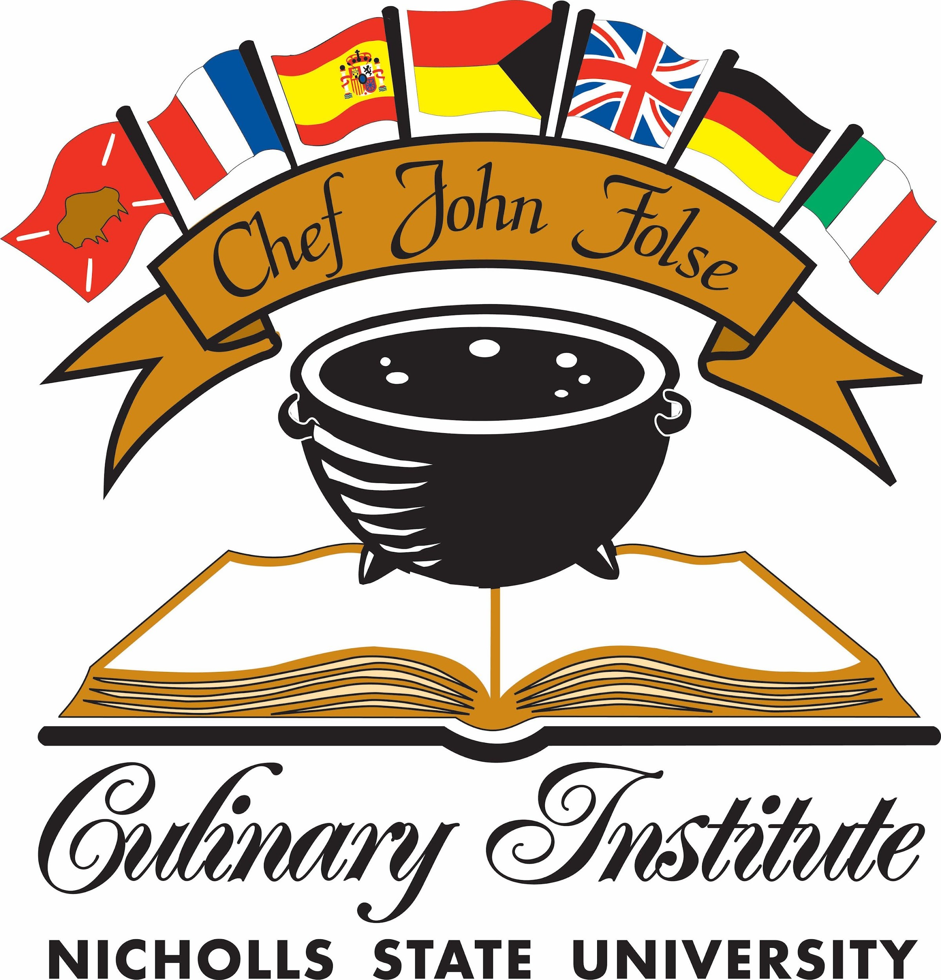John Folse Culinary Institute
Ancho Aioli
CULA 315 Chef Jana
Source:https://thespicetrain.com/ancho-aioli/#recipe
Yield: Four (1 oz.) Servings
0.5 Cup mayonnaise  2 Teaspoon ancho chili powder  4 small garlic cloves, peeled, minced, and grated  0.5 Teaspoon unseasoned rice vinegar | Add all ingredients to the bowl and whisk until evenly combined

John Folse Culinary Institute
Pickled Red Onions
CULA 315 Chef Jana
Source:https://www.bonappetit.com/recipe/quick-pickled-onions
Yield: 20 servings
½ Cup apple cider vinegar  1fl. Cup Water  1 Tbsp Sugar  ¾ Tablespoon Kosher Salt  1 Red Onion, thinly sliced | Heat apple cider vinegar, sugar, water, and salt in saucepan, then cut heat off right before boiling. Place red onions in a proper container, then pour vinegar mixture on top of onions. Let cool, label, then place in walk-in.

John Folse Culinary Institute
Recipe Name: Biscuits
Class and Instructor: CULA 315 Chef Jana
Source: https://www.pauladeen.com/recipe/southern-biscuits/
Yield: 3 dozen small biscuits/1 dozen large biscuits
 | Preheat oven to 425.
2 cups flour  1 tsp sugar  1 tbsp baking powder  1 tsp salt | Mix together.
8 tbsp cubed butter  ¾ cup milk | Cut in butter until it becomes like cornmeal. Make a well and add milk and knead.
 | Roll out to desired thickness and cut with biscuit cutter.
 | Butter a pan and put in biscuits. Bake 12 minutes or until golden.

John Folse Culinary Institute
Recipe Name: Peach Honey Butter
Class and Instructor: CULA 315 Chef
Jana
Source: https://www.food.com/recipe/peach-honey-butter-204660
Yield: 10 servings
16 oz can peach, drained  1 cup butter  1 tsp cinnamon  ¼ tsp nutmeg  2 tbsp honey  ½ tsp salt | Temper butter. Puree peaches with spices and honey. Combine and whipped together in a mixer.

John Folse Culinary Institute
Sous Vide Pork Chop
CULA 315 Chef Jana
Source: https://www.theseasonedmom.com/honey-garlic-dijon-pork-tenderloin-marinade/#recipe-variations, https://www.youtube.com/watch?v=dUK_0o8aMe0
Yield: 2 Servings, 1-1 ½ in. thick
(2) 1-1 ½ in. thick pork chops, Frenched  ½ Cup Honey  ½ Cup Dijon Mustard  2 Tbsp. Worcestershire sauce  2 Tbsp. Apple Cider Vinegar  1 Tbsp. Garlic, Minced  1 stem Rosemary  1 Stem Thyme | Whisk all ingredients together. Place chop in vacuum seal bag, along with marinade, and seal to contain. let marinate for 24 hours. Once finished, Prep sous vide station and sous vide marinated pork chops at 125 degrees (F) for 1 hour and 15 minutes.  Once finished, take out and immediately place in an ice water bath and hold for service.
TT Salt  TT Pepper  1 Tbsp. Chopped Parsley | For service, Take out of the bag and sprinkle with salt and pepper. Grill until the chop reaches 145 degrees (F). Place on top of brussels and garnish with parsley.

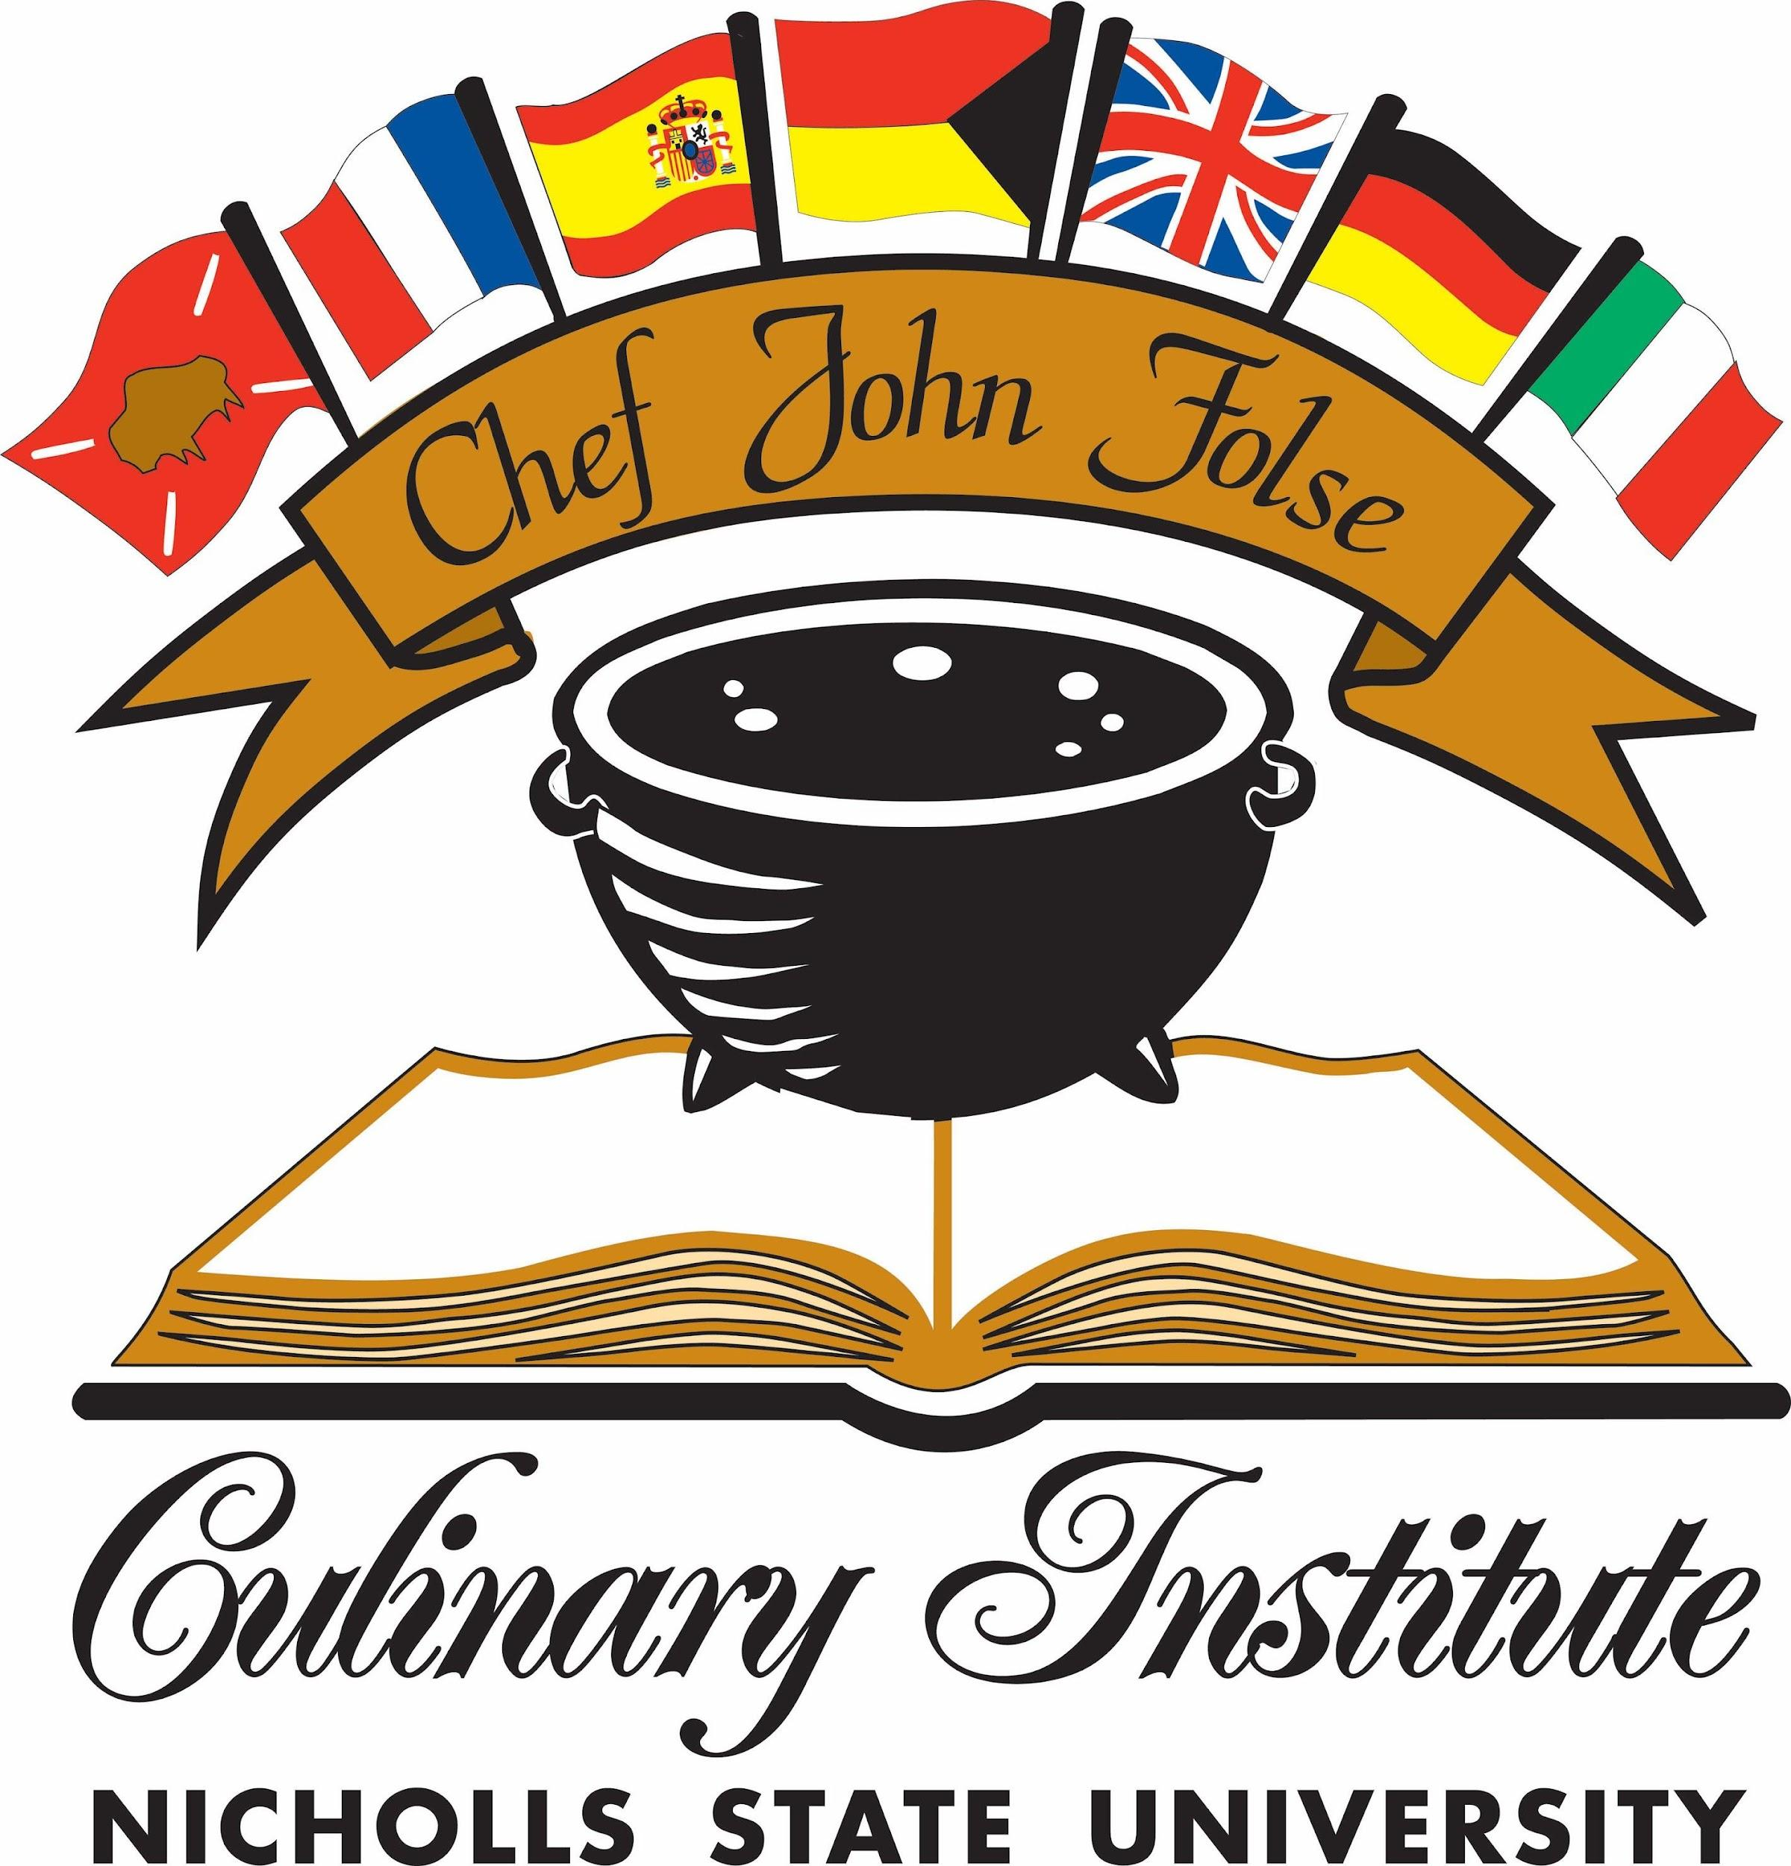John Folse Culinary Institute
Polenta
CULA 315 Chef Jana
Source: https://www.allrecipes.com/recipe/83311/cheesy-polenta/
Yield: 8 Servings
2 Cups Whole milk  2 Cups Water  1 ½ Tsp. Kosher Salt  1 Cup polenta  4 tbsp. unsalted butter  ½ tsp. ground pepper  4 oz colby jack cheese | Combine milk, water, and kosher salt in a large pot over medium-high heat; bring to a boil. Gradually whisk polenta into boiling milk-water mixture. Reduce heat to low and cover. Simmer until creamy, about 20 minutes, lifting the lid and stirring every 3 to 4 minutes to prevent sticking.
TT Salt  TT Pepper | Remove the pot from heat. Stir in butter and pepper until incorporated. Gradually stir in cheese until melted. Serve hot.

John Folse Culinary Institute
Peach Whiskey Barbeque Sauce
CULA 315 Chef Jana
Source:https://www.thepioneerwoman.com/food-cooking/recipes/a10290/peach-whiskey-barbecue-
chicken/
Yield: 6, 1-oz servings
1 ½ Cups whiskey (Crown Royal Peach)  12 fl. oz. barbeque sauce  1 (16 oz) Jar peaches  ½ Cup Water  14 oz. Worcestershire Sauce  4 Garlic cloves | Pour whiskey, barbeque, peaches, water, worcestershire sauce, and garlic cloves into a pot and mix. Using the immersion blender, blend everything together in the pot. Once blended, let simmer for 15 minutes. Once finished, strain the sauce.

John Folse Culinary Institute
Sauteed Brussel Sprouts with Bacon and Onion
CULA 315 Chef Jana
Source: https://www.food.com/recipe/yummy-brussels-sprouts-with-bacon-onion-335212
Yield: Four, 4-oz Servings
4 slices thick bacon, cut into ½ in.  1 small onion, small diced  1 Tbsp EVOO | Cut up bacon and cook in the oven. Once finished, strain and save bacon fat. Store bacon in a container.  Heat the pot for onions. Once heated, add olive oil. Add onions and slowly cook until caramelized. Once finished, place in a container and let cool. Then store in the walk-in.
1 lb. Brussel Sprouts  TT Salt | Blanch Brussel Sprouts in salted water for 3-4 minutes. Once finished, remove from water, and shock the sprouts in ice water. Once Sprouts are dry, cut the stem off, then cut in half.
 | Place brussels on a sheet pan lined with parchment paper. Bake at 350 for 8-10 minutes or until slightly roasted. Once finished, let cool.
TT Salt  TT Pepper | To finish cooking the brussels, heat a pan and add bacon fat. Add brussels and saute. when they are nearly browned, add the cooked bacon, onions, salt, and pepper to the pan and continue to saute until finished.
Chef John Folse Culinary Institute
Recipe Name: Brisket
Instructor: Chef Jana
Source/Serving: yield:46 https://www.youtube.com/watch?v=kE2RisA2mHY&list=WL&index=66
35 lbs brisket  7 oz salt  7 oz black pepper | Trim the brisket and cover with salt and pepper.
 | Keeping the smoker between 225-250 smoke for three hours.
1 qt apple cider vinegar  1 qt shiner | Mix together. Spray any exposed meat every 30 mins.
 | Raise temperature to 250-275. Give the tallow another hour then remove and let cool.
12 oz beef tallow | When there is a crisp bark, the fat is rendered, and the brisket is around 165 degrees wrap with butcher slathered with smoked tallow.
 | Remove brisket when internal temp is 203 and the probe pierces meat easily.
 | Cut into two serving blocks and then slice before service. Let brisket rest in a cooler for 2-12 hours. Check temp before serving and bring back up to serving temp if necessary.
4 bunches of green onions, cut into curls, stored in ice water | Lay 6 oz brisket sliced into ¼ in. pieces on the plate. Spoon 2 oz gastrique on top. Serve with 3 oz collard greens and a bowl of equal amount mac and cheese. Garnish with green onion curls.

John Folse Culinary Institute
Recipe Name: Cajun Pepper Jelly Gastrique
Class and Instructor: CULA 315 Chef Jana
Source: https://frugalhausfrau.com/2016/02/15/cajun-gastrique/
Yield: 3 servings
½ cup sugar  2 tbsp water | add sugar and water to a pot. Stir occasionally with med heat until sugar is melted. When sugar is melted, stop stirring and let the mixture cook to an amber color.
½ cup cane vinegar  1 tbsp cajun seasoning  ½ cup pepper jelly | Add vinegar, seasoning, and pepper jelly mix in and cook to a light syrup consistency.

John Folse Culinary Institute
Recipe Name: Collard Greens
Class and Instructor: CULA 315 Chef Jana
Source: https://www.southernliving.com/recipes/southern-collard-greens
Yield: 10 servings
12 bacon slices finely chopped  2 med sweet onions  6 garlic cloves finely minced  ¾ lbs ham chopped | Cook bacon in the stock pot until almost crisp. Add onions and cook 8 mins. Add garlic and ham and cook for 1 min.
3 qt chicken stock  3 lbs collard greens  ⅓ cup apple cider vinegar  1 tbsp sugar  1 tsp salt  ¾ tsp black pepper | Add everything and simmer for 2 hours until tender.

John Folse Culinary Institute
Recipe Name: Mac and Cheese
Class and Instructor: CULA 315 Chef Jana
Source: https://www.southernliving.com/recipes/best-ever-macaroni-and-cheese-recipe
Yield: 12 servings
 | preheat oven to 250
16 oz elbow mac | boil pasta
6 tbsp butter  ⅓ cup grated yellow onion  2 tsp dry mustard  1 tsp salt  ¼ tsp black pepper  ⅛ tsp nutmeg  ⅛ tsp cayenne  6 tbsp flour  3 ½ cup milk  1 ¾ cups heavy cream  2 tsp worchestire  6 oz shredded Gruyere  6 oz shredded cheddar | Melt butter over med heat. Add onion and seasoning and cook for 30 seconds. Add flour and cook until golden brown. Slowly whisk in milk and cream. Cook 5 min while whisking occasionally until thickened. Add worchestire. Stir in cheese and melt.
2 oz shredded colby jack  2 oz shredded gruyere | Pour into a greased baking dish and bake for 30 mins. Add cheese to top and broil.

John Folse Culinary Institute
Recipe Name: Blackened Redfish
Class and Instructor: CULA 315 XA, Chef Jana
Source: https://www.saveur.com/article/Recipes/Blackened-Redfish/
Yield: 6 Servings
1 tbsp. sweet paprika  2 1⁄2 tsp. salt  1 tsp. onion powder  1 tsp. garlic powder  1 tsp. cayenne  3⁄4 tsp. ground BP  3⁄4 tsp. ground WP  1⁄2 tsp. dried thyme  1⁄2 tsp. dried oregano  11 oz. butter, melted  (6) 8 oz. 1/2-inch–thick filets skinless, boneless red drum, black drum, or red snapper | 1. Combine paprika, salt, onion and garlic powders, cayenne, black and white pepper, thyme, and oregano in a small bowl and set aside. Put 2 tbsp. of the butter into six small ramekins; set aside and keep warm. Put remaining butter into a wide, shallow dish. Dip each filet in butter and place on a parchment paper-lined sheet tray. Dust each filet generously on both sides with spice mixture, pressing spices and herbs into the fish with your hands. Pour remaining butter into a small bowl.
 | 2. Preheat oven to 200F. Heat a large cast-iron skillet over high heat until white and ashy, 8-10 minutes. Carefully place 2-3 filets in pan. Pour 1 tsp. of the remaining butter over each filet. Cook until the bottom of each filet appears charred, about 2 minutes. Turn filets over and pour 1 tsp. butter over each. Continue cooking until fish is cooked through. Transfer to a sheet tray on a rack and keep warm in the oven. Repeat the cooking process with the remaining fish and butter. Serve with reserved warm melted butter.

John Folse Culinary Institute
Recipe Name: Sauteed Broccolini
Class and Instructor: CULA 314 XA, Chef Jana
Source: https://www.foodnetwork.com/recipes/ina-garten/sauteed-broccolini-recipe-1944683
Yield: 6 Servings
1 bunch broccolini  Kosher salt | Blanch the broccolini in a large pot of boiling salted water for 2 minutes. Drain immediately and immerse in a bowl of ice water.
2 tbsp. unsalted butter  1/2 lemon, zested  1 tsp. minced garlic  1 tbsp. lemon juice  1/4 tsp. ground BP | Melt the butter in a large saute pan. Add the lemon zest and garlic and stir. Drain the broccolini, add it to the garlic mixture, and heat for 2 minutes. Add the lemon juice, 1/2 teaspoon salt, and pepper, and toss well before serving.

John Folse Culinary Institute
Recipe Name: Beurre Blanc
Class and Instructor: CULA 315 XA, Chef Jana
Source: https://www.simplyrecipes.com/classic-beurre-blanc-sauce-recipe-5225084
Yield: 1 cup (6 servings)
9 tbsp cold, unsalted butter, divided  3 tbsp shallots, finely chopped  3 tbsp dry white wine  2.5 tbsp. white wine vinegar  2 tbsp. lemon juice | Melt one tablespoon of butter over medium heat in a medium heavy-bottomed saucepan. Add the shallots and cook, stirring, until shallots are soft and translucent but not browned, 1 to 2 minutes. Stir in the dry white wine, white wine vinegar, and lemon juice; cook, stirring occasionally, to reduce the liquid until about 2 to 3 tablespoons remain.
1/3 c. heavy cream  1/8 tsp. kosher salt  1/8 tsp. WP | Add the cream and salt to the pan and bring to a boil over medium heat and cook, stirring, for 1 minute. Pour the sauce through a fine-meshed strainer into a small bowl and press down using a spoon to extract as much liquid as possible. Rinse out the saucepan.
 | Return the strained sauce to the pan and reduce the heat to low. Whisking vigorously, add the remaining eight tablespoons of butter, a few pieces at a time. When each addition is incorporated, add more butter until it is incorporated, the sauce looks creamy and coats the back of a spoon. It will resemble heavy cream. Stir in the salt and pepper. Serve immediately or hold lukewarm (the sauce can break).

John Folse Culinary Institute
Recipe Name: Wild Rice and Toasted Pecan Pilaf
Class and Instructor: CULA 315 XA, Chef Jana
Source: https://www.epicurious.com/recipes/food/views/wild-rice-and-toasted-pecan-pilaf-11694
Yield: 8 Servings
 | Preheat the oven to 375F.
1 c. pecan halves, chopped coarse  2 tbsp. unsalted butter, melted  3/4 tsp. dried thyme  1/4 tsp. salt | In a small baking pan, toss the pecans with the butter, the thyme, and the salt until they are coated well, and toast them in the middle of the oven for 10 minutes or until they are crisp and fragrant.
1 large onion, halved lengthwise and sliced thin lengthwise  1 yellow bell pepper, cut into julienne strips  1/4 c. olive oil  2 1/2 c. wild rice, rinsed well  4 1/2 c. chicken broth | In a medium pot, cook the onion and the bell pepper in the oil over moderately low heat, stirring, for 5 minutes, or until they are softened, and with a slotted spoon, transfer them to a bowl. Add the rice to the pot and cook it, stirring constantly, for 1 minute. Stir in the broth, heated to boiling, salt and pepper to taste, and bring the mixture to a boil. Bake the mixture, covered, in the middle of the oven for 40 minutes. Stir in the onion mixture, bake the pilaf, covered, for 30 minutes more, or until the rice is tender and the broth has been absorbed, and stir in the pecans.

John Folse Culinary Institute
Recipe Name: Brioche Bread Pudding
Class and Instructor: CULA 315 XA, Chef Jana
Source: https://foodfunfamily.com/brioche-bread-pudding-with-caramel-sauce/
Yield: 12, 4-oz servings
 | Preheat oven to 350F.
1 stick butter, unsalted  6 c. Brioche bread, cut into 1-in. cubes  4 c. heavy cream  4 eggs, beaten  2 c. sugar  1 tsp. cinnamon  2 tbsp vanilla | Melt the butter in a casserole dish in the oven while it preheats. Cut the brioche bread. Combine milk, eggs, sugar, cinnamon, and vanilla in a large bowl; mix. Add cubed bread and stir to mix. Pour mixture into hot, melted butter in the casserole dish.
 | Bake for 50 minutes or until the center starts to get firm. Let the bread pudding cool for several minutes and prepare to serve.

John Folse Culinary Institute
Recipe Name: Sweet Potato Ice Cream
Class and Instructor: CULA 315 XA, Chef Jana
Source: https://inkristaskitchen.com/homemade-sweet-potato-ice-cream/#recipe
Yield: 28, 2-oz servings
1 lb. sweet potatoes | Preheat the oven to 400F, then line a sheet tray with parchment paper. Roast the sweet potatoes until they're soft with a brown syrupy sauce oozing out of them, 60-90 minutes. Let them cool slightly and peel them. Puree the sweet potatoes in the food processor until smooth and set aside.
2 c. heavy cream  2 c. whole milk  1 c. brown sugar  ½ c. sugar, granulated  7 egg yolks | Add the egg yolks to a heat-proof bowl then set aside until needed. Whisk the heavy cream, milk, brown sugar, and granulated sugar in a medium sauce pot. Bring it to a simmer over medium-low heat. DO NOT BOIL. The temperature should be around 195F. Remove the cream mixture from the heat as it simmers. Add ¼ c. of the hot cream mixture to the bowl of egg yolks while whisking continuously and vigorously. Repeat 4-5 times to temper the egg yolks.
1½ tsp vanilla extract  1 tsp kosher salt | Pour the egg mixture back into the hot pan of cream while whisking. Heat the pan over low-medium heat while whisking constantly until it simmers again, about 195F. Remove from heat immediately and stir in the vanilla and salt. Strain through a fine mesh strainer into a medium-sized mixing bowl. Whisk in the sweet potatoes until smooth. Fill a large mixing bowl with ice and a little water. Set the medium-sized bowl inside the large bowl to chill the ice cream mixture. Whisk the mixture every 10 minutes until cooled.
Once the mixture is fully cooled, add it to the ice cream machine and churn according to manufacturer's instructions. Pour the ice cream mixture into a vessel then freeze for 6-8 hours.
Remove the ice cream from the freezer 5-10 minutes before scooping it to serve.

John Folse Culinary Institute
Recipe Name: White Chocolate Sauce
Class and Instructor: CULA 315 XA, Chef Jana
Source: https://sundaysuppermovement.com/white-chocolate-sauce/#recipe
Yield: 1 quart
1 c.Whole milk  3 c. White chocolate chips | Add the milk and chips to a saucepan over medium-low heat and stir constantly to slowly melt the chocolate. Keep stirring until the chocolate is fully melted, then remove immediately and let cool. Bottle, then use immediately or store in the fridge.

John Folse Culinary Institute
Recipe Name: Butterscotch Candy
Class and Instructor: CULA 315 Chef Jana
Source: https://pastrychefonline.com/butterscotch-candy/#recipe
Yield:64 pieces
 | Line the pan with foil or parchment paper. Making sure that there is excess hanging off the ends. Spray with pan spray.
1 lbs unsalted butter  10g salt  4 oz water  4 oz molasses | Melt the butter with the salt. When half melted add water and molasses.
1 lbs sugar | When completely melted add sugar and raise heat. Bring to a boil and stir until sugar is dissolved.
 | Once the mixture reaches 250 pour into pan.
 | Score into properly sized squares and separate from sides. Cover with a towel and let it sit out for 24 hr. After that remove and cut.

