In order to evaluate CAEP Standard 4.1 (Completer Effectiveness), two of the Louisiana State Department of Education’s teacher assessment tools were analyzed for 45 program completers. All of the program completers self-reported this data, as it was not made readily available by the State. The survey sent out by the EPP, which had 53 total respondents, indicated that 34 program completers were evaluated via the COMPASS evaluation system, while 11 were evaluated by the TAP system, while eight were not evaluated using either system, as they are not teaching the in public school system. Below is a description of the data collected from each evaluation system, which accounts for student learning growth and the program completers’ application of their teaching knowledge and skills, as well as all of the professional preparation to become a teacher in the public school system provided by the EPP. The data analyzed below is the best indicator for both student growth and teacher effectiveness in the state of Louisiana.
COMPASS is Louisiana’s educator support and evaluation system. COMPASS aims to provide all teachers, counselors, librarians and school leaders with regular, meaningful feedback on their performance with the ultimate goal of fostering continuous improvement and helping educators have a greater impact on student learning. There are two parts of COMPASS, Student Growth and Professional Practice. Each part accounts for half of the annual Compass evaluation, which includes assessment of student data, one formal observation and one informal observation (LDOE).
Due to the lack of data for COMPASS scores provided by the Louisiana State Department of Education for the 2018-2019 school year, a survey was created to have program completers self-report their scores. The total number of respondents for this portion of the survey was (n=34). Figure 1 (below) depicts the categorical dispersion of scores. Percentages of respondents falling in each category were calculated to determine the range of scores and the rated quality of the program completers for the COMPASS evaluation. Overall, no program completers were found to fall within the ineffective category, with the vast majority being ranked at the effective proficient level or above.
- For the assessment category related to Setting Instructional Outcomes, 97% of respondents were found to be in the effective proficient (55%) or highly effective (41%) categories.
- In the Managing Classroom Procedures category (2c), 94% of program completers were found to be in the effective proficient (35%) or highly effective (59%) categories.
- For the assessment category of Using Questioning Prompts and Discussion (3b), 88% of program completers were found to be in the effective proficient (53%) or the highly effective (35%) categories.
- For the assessment category of Engaging Students in Learning (3c), 94% of program completers were found to be in the effective proficient (38%) or the highly effective (56%) categories.
- For the assessment category of Using Assessment in Instruction (3d), 85% of program completers were found to be in the effective proficient (53%) or the highly effective (32%) categories.
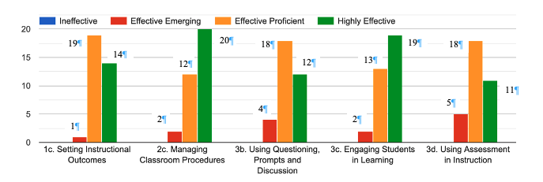
Figure 1. COMPASS Scores by Category
Additionally, TAP scores were reported by program completers, again due to the lack of data provided by the LDOE, this information was collected via a voluntary survey sent by the EPP. The TAP rubric includes 4 domains and 26 indicators across those four domains. An annual SKR (Skills, Knowledge, and Responsibility) Score is computed for each teacher evaluated using the TAP rubrics. The SKR is based on multiple observations by multiple trained and certified evaluators.
Overall, 11 program completers responded to this portion of the survey. The TAP scores are on a scale of 1 to 5 (1=unsatisfactory, 2= below expectations, 3=proficient, 4= above expectations, 5= exemplary). The following are the average scores in each category for the 11 completers:
- Standards and Objectives Average Score=3.45
- Motivating Students Average Score= 3.81
- Presenting Instruction Content Average Score= 3.64
- Lesson Structure and Pacing Average Score= 3.36
- Activities and Materials Average Score= 3.36
- Questions Average Score=3.36
- Academic Feedback Average Score= 3.55
- Grouping Students Average Score=3.55
- Teacher Content Knowledge Average Score= 3.82
- Teacher Knowledge of Student Average Score= 3.64
- Thinking Average Score=3.18
- Problem Solving Average Score=3.27
- Instructional Plans Average Score= 3.27
- Student Work Average Score=3.27
- Assessment Average Score= 3.18
The total average score across all candidates was 3.45, with the highest average score achieved in the Motivating Students and Teacher Content Knowledge categories.

