CAEP Standard 4
Initial Program Completer Data; MEASURE 2
Nicholls State University
CAEP 2022 Annual Report

Measure 2: Initial Satisfaction of Employers and Stakeholder Involvement
To address Employer Satisfaction, the EPP launches annual surveys to principals aligned to the 10 InTASC standards. Employers are asked to rate EPP initial program completers employed at their institution on a 5 point Likert scale ranging from Strongly Disagree, Disagree, Neutral, Agree and Strongly Agree on the employees ability to fulfill the criteria of each InTASC standard. Employers were also asked for additional comments on each program completer.
The EPP emailed each principal a survey for every EPP program completer employed in their institution. The email included the name of the program completer and a link to the survey. If an employer had three program completers employed at the institution, the employer received three separate emails specific to the individual program completer. The EPP finds this strategy to be effective in obtaining a response rate about 20% The Fall 2020 response rate = 33% and Spring 2021 response rate = 24%
Overall, the employers completing the survey for 20-21 (N=24) indicated that they were satisfied/very satisfied with the EPP’s program completers as teachers. The majority of employers either agreed or strongly agreed that the program completers met the InTASC Standards. Twenty Two principals (92%) scored program completers as Agree or Strongly Agree for meeting the InTASC standards. In fall 2020 and spring 2021, two principals (8%) scored two of the EPP’s program completers as unsatisfactory on the majority of InTASC standards. The CAEP coordinator and Director of Clinical Practice and Residency reviewed the programs and performance of these two program completers and did not see any deficiencies in dispositions, coursework or residency experiences during their tenure at the EPP. The candidates were in two different programs and employed at two different schools.
The indicators that had the lowest Strongly agree scores included the following InTASC standards: The teacher understands and uses multiple methods of assessment to engage learners in their own growth, to monitor learner progress, and to guide the teacher’s and learner’s decision making. (InTASC Standard #6: Assessment, CAEP R1.3 Instructional Practice), The teacher engages in ongoing professional learning and uses evidence to continually evaluate his/her practice, particularly the effects of his/her choices and actions on others (learners, families, other professionals, and the community), and adapts practice to meet the needs of each learner. (InTASC Standard #9: Professional Learning and Ethical Practice, CAEP R1.4 Professional Responsibility), and The teacher seeks appropriate leadership roles and opportunities to take responsibility for student learning, to collaborate with learners, families, colleagues, other school professionals, and community members to ensure learner growth, and to advance the profession. (InTASC Standard #10: Leadership and Collaboration, CAEP R1.4 Professional Responsibility). The EPP continues to monitor the results of the Employer surveys to determine areas of continuous improvement.
The EPP is presently completing the Transition Plan for CAEP 4.2 In order to establish survey content of the Employer Satisfaction Survey, the EPP conducted the Lawshee Method asking faculty to rank each question on the survey as "Essential, Not Essential But Useful, or Not Useful." The Teacher Education Math Faculty conducted the Lawshee calculations with the following two questions being identified as those that should be deleted: "Additional comments about this teacher." and "Please rate this statement: I prefer to recruit / hire Nicholls' Teacher Education graduates over graduates from other programs." AQAT met and discussed the irrelevance of these items and determined that they could be deleted. The CAEP Coordinator asked faculty for input at the March Faculty Assembly and there were no objections to the deletion of these two questions. The survey was updated and data quality will be examined when administered to F21-S22 employers of program completers.

Fall 2020
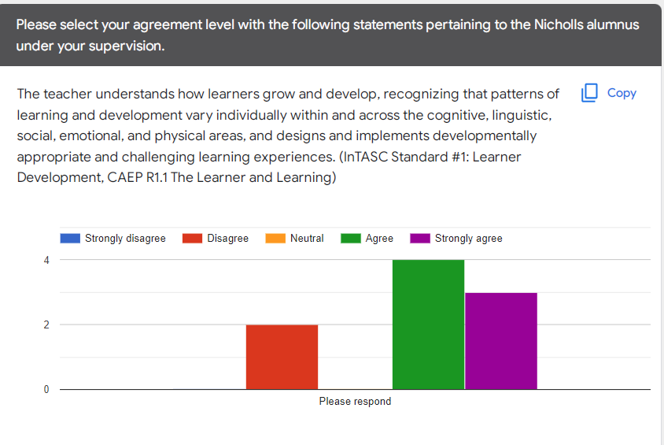
Spring 2021
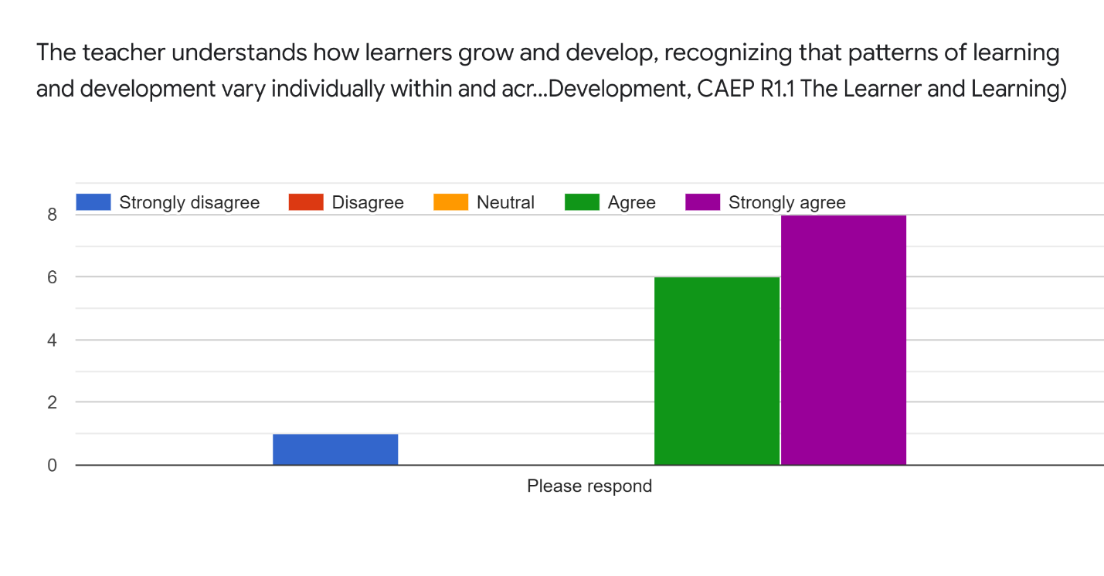

Fall 2020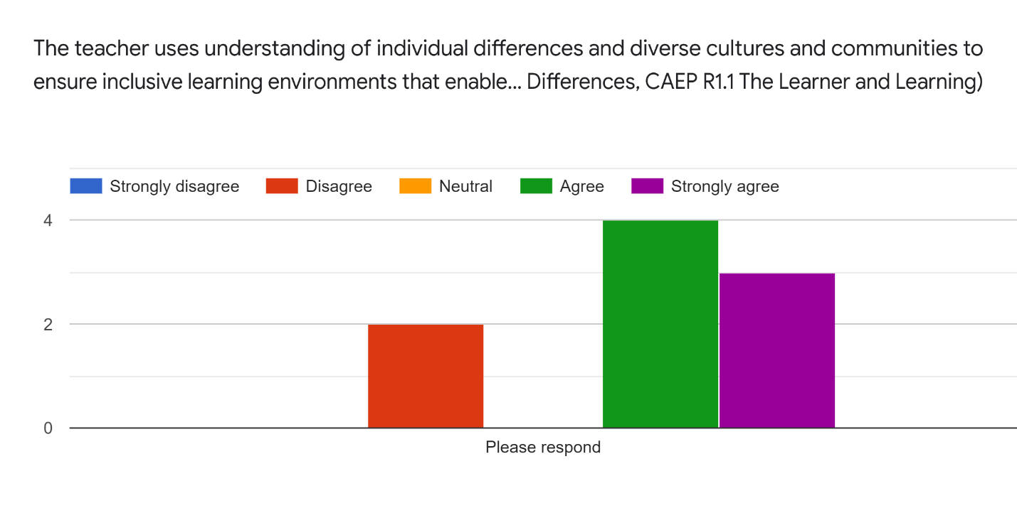
Spring 2021
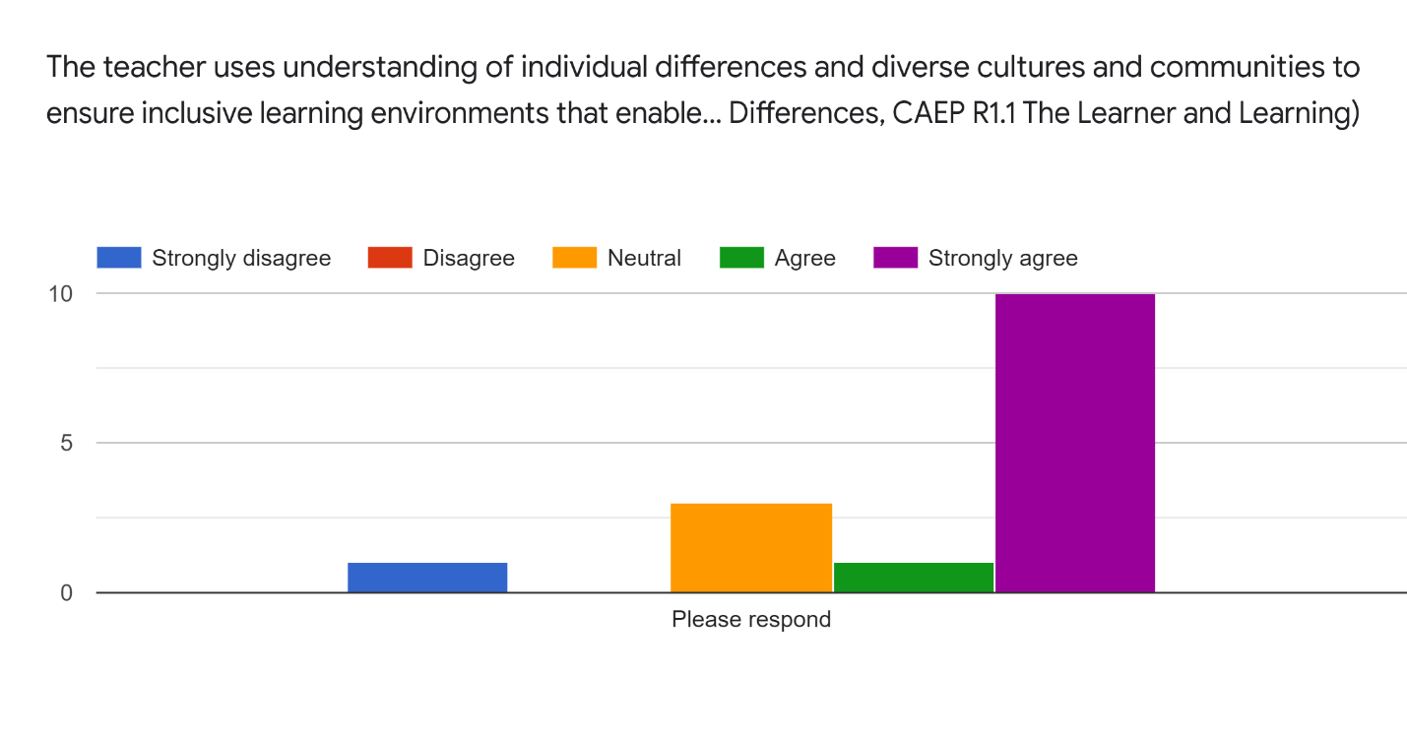

Fall 2020
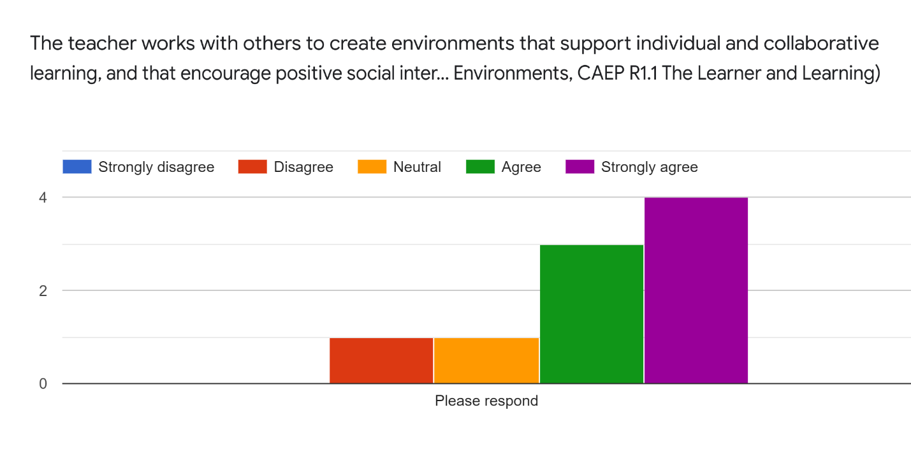
Spring 2021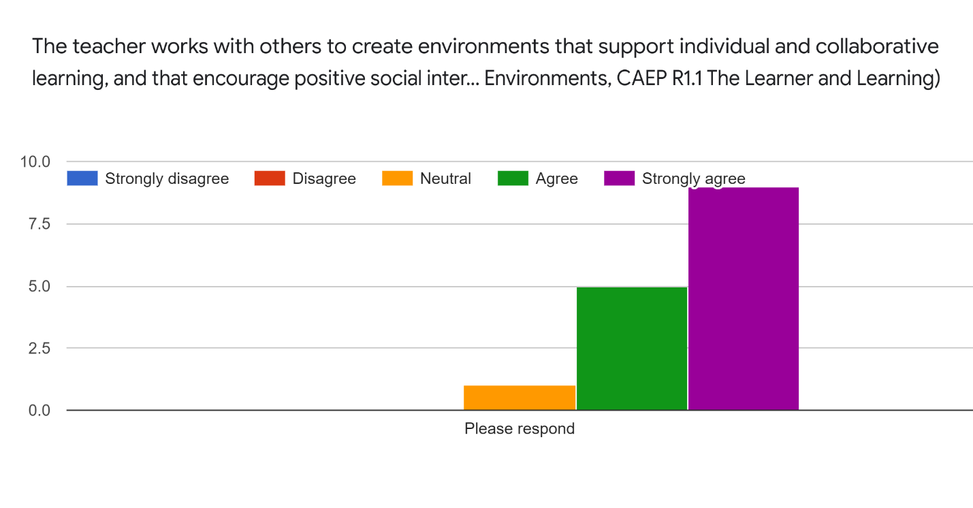

Fall 2020
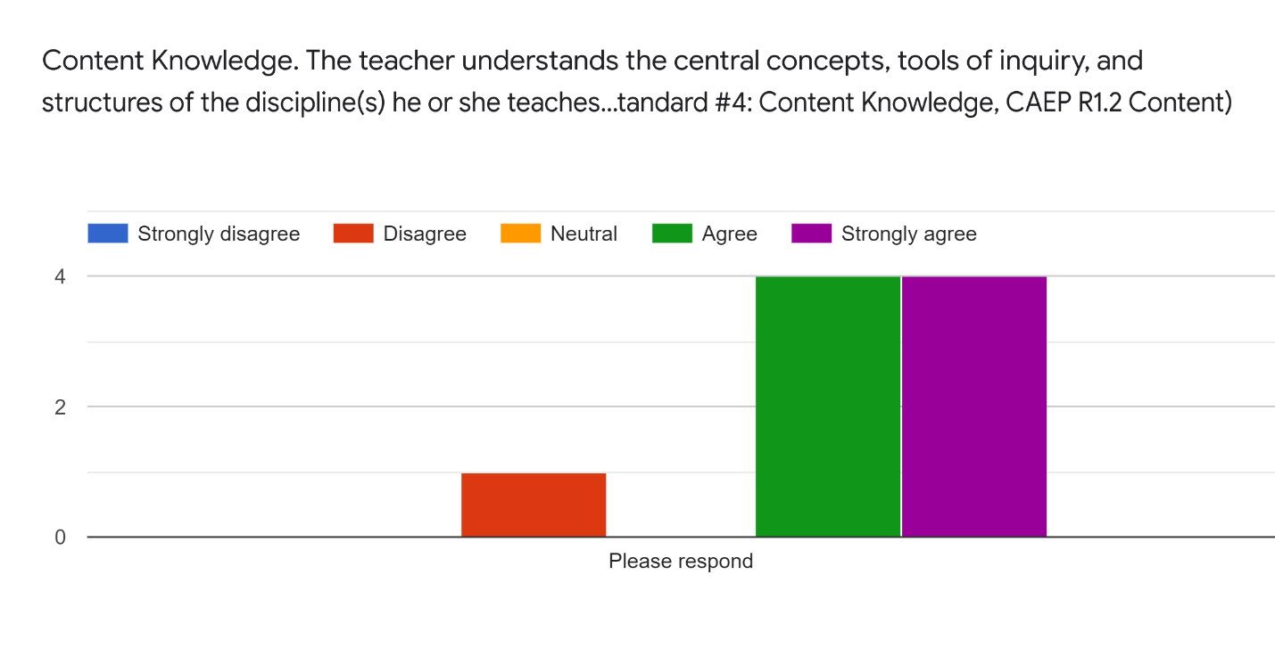
Spring 2021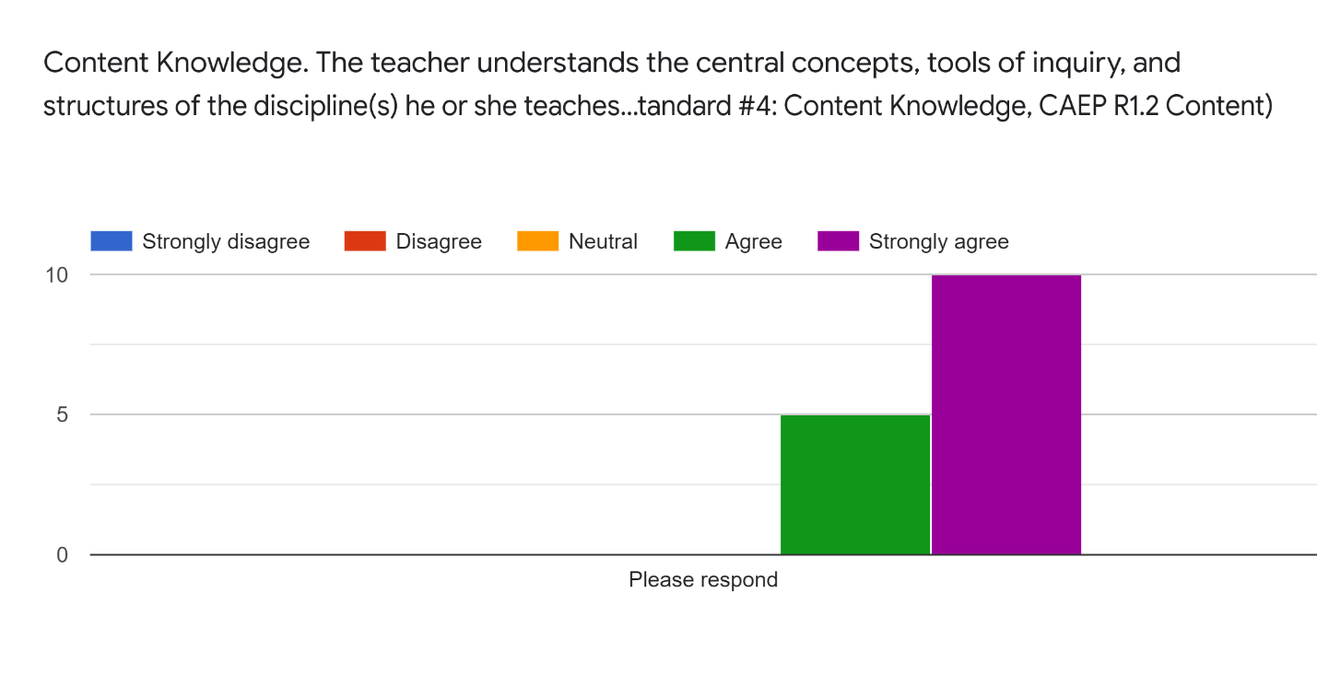

Fall 2020
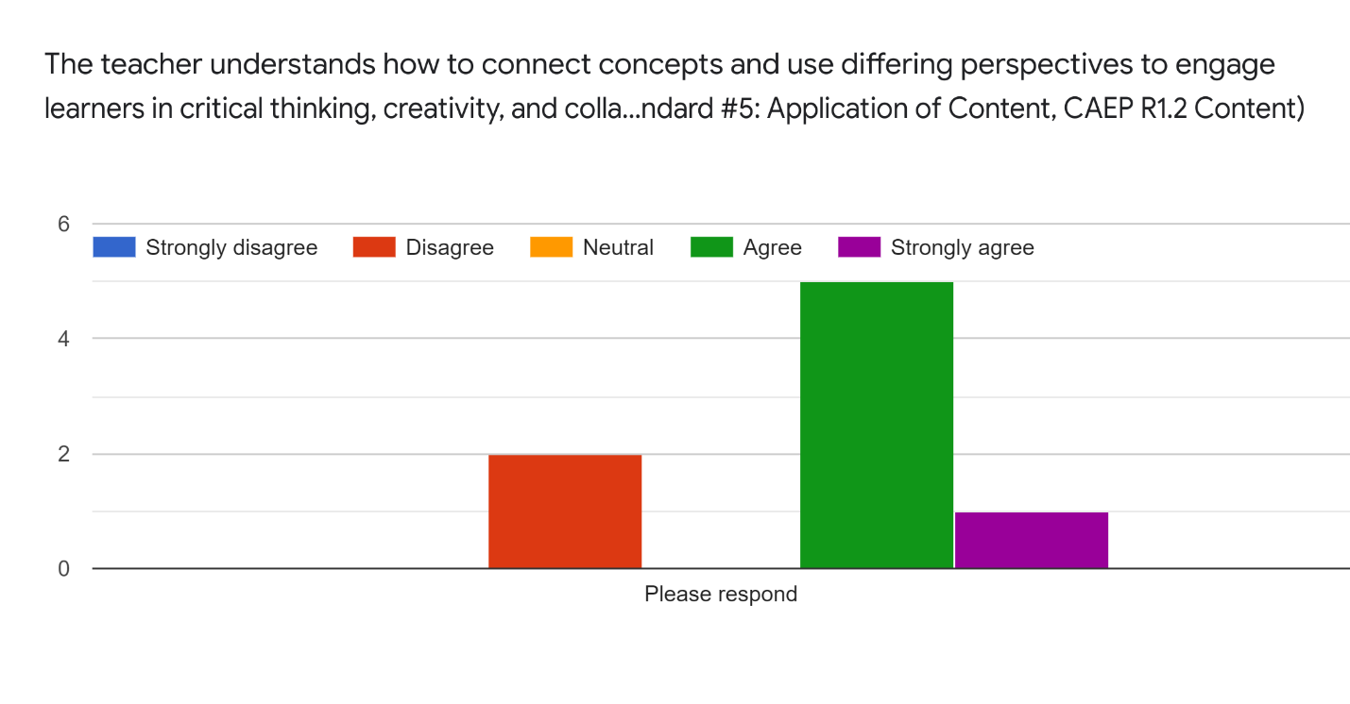
Spring 2021
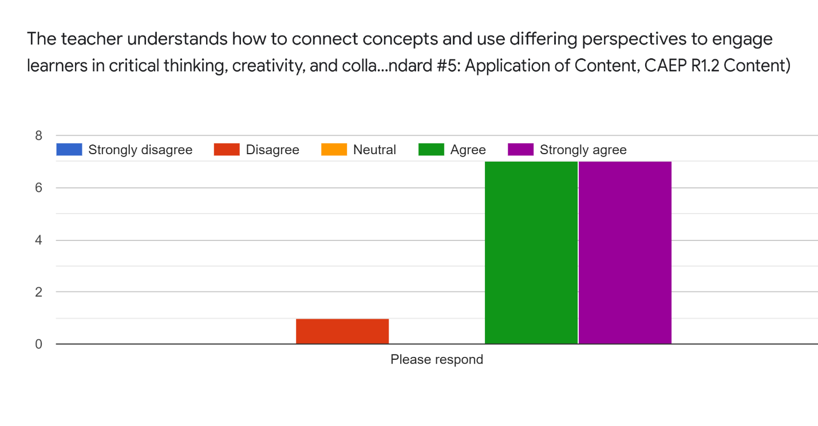

Fall 2020
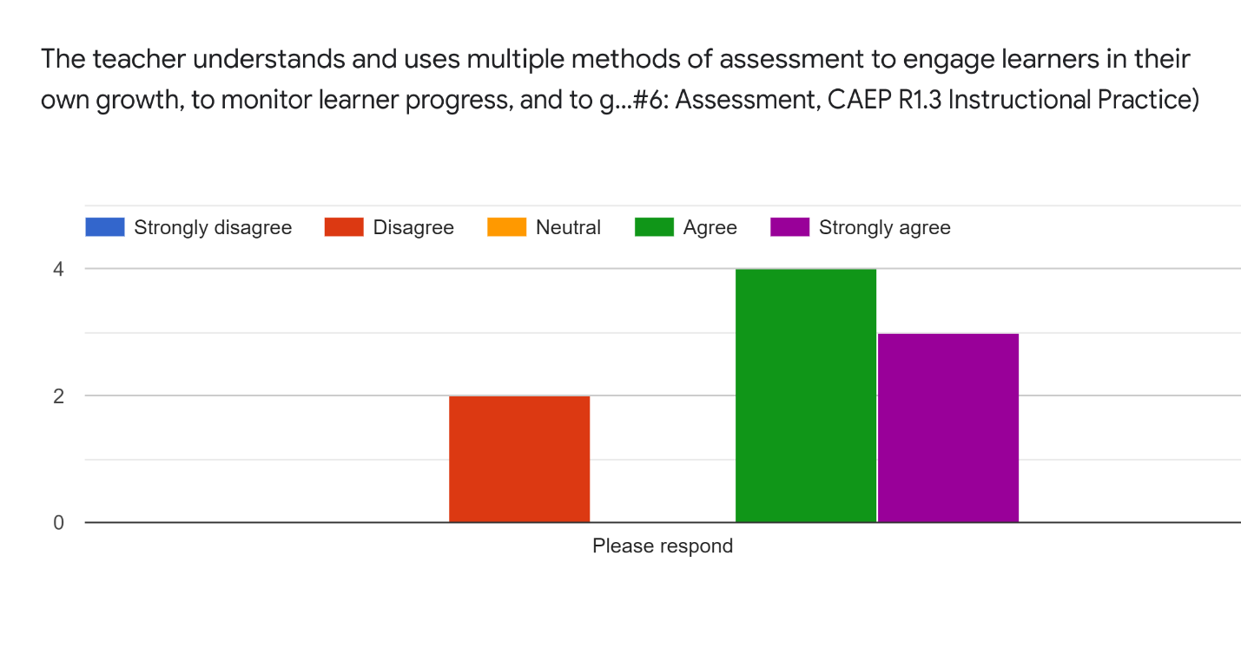

Spring 2021
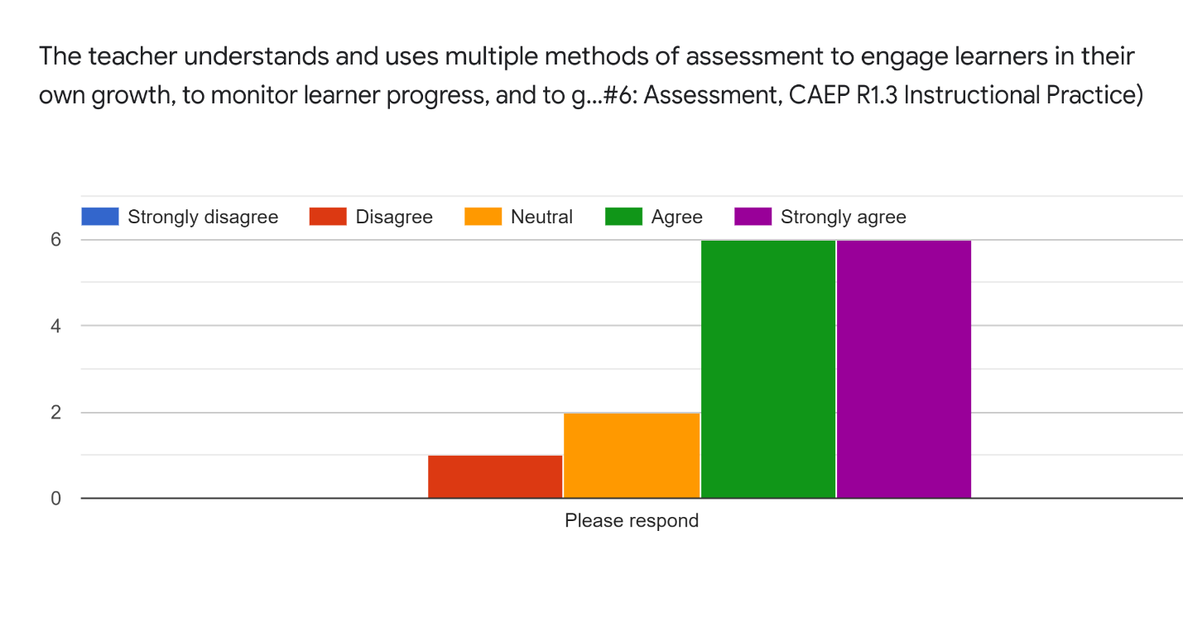

Fall 2020

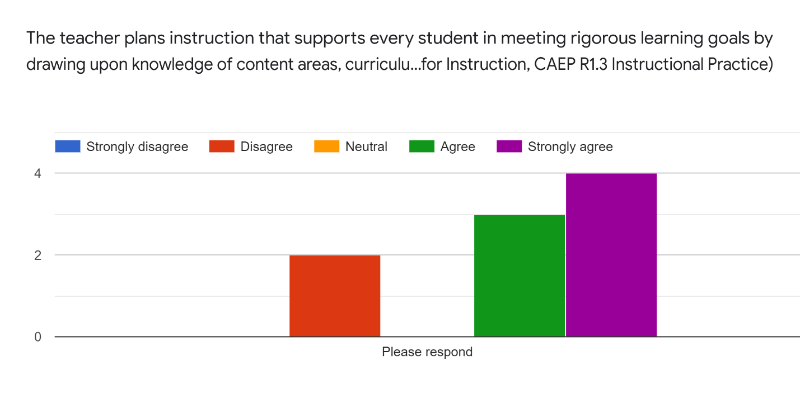
Spring 2021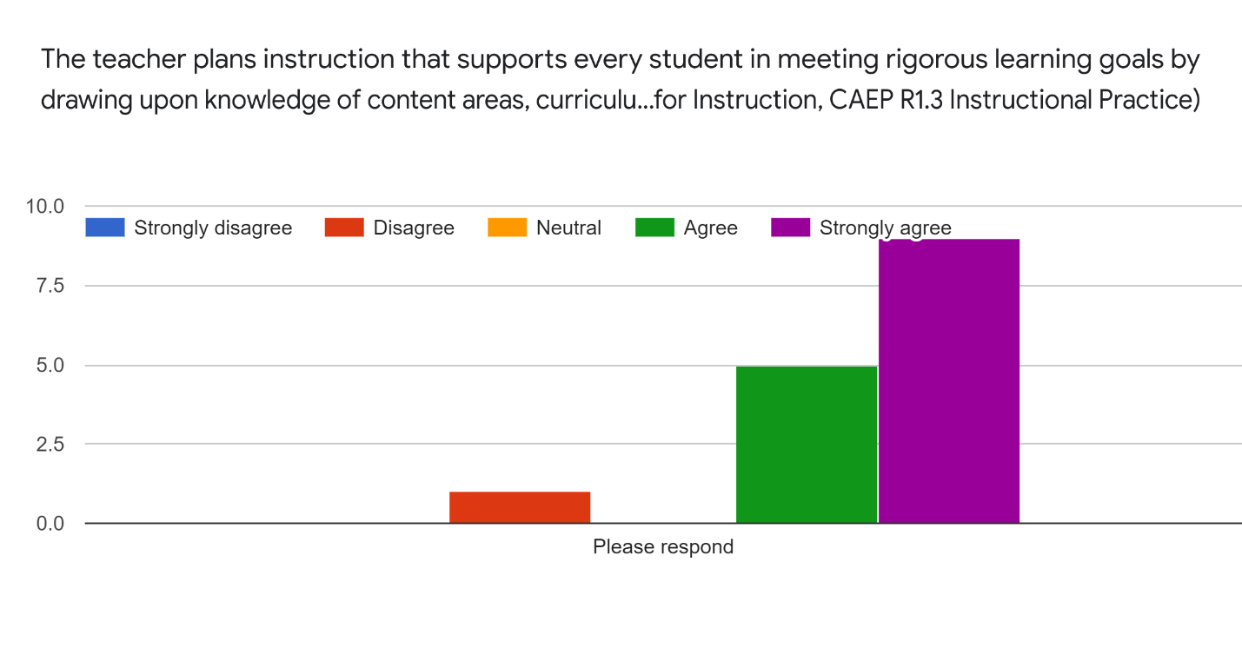

Fall 2020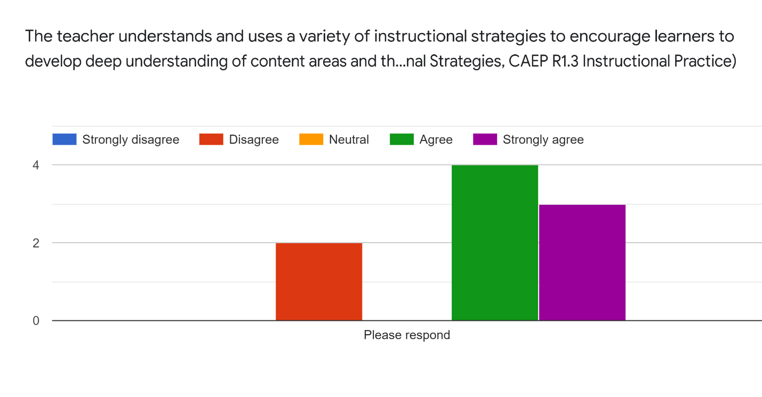Spring 2021
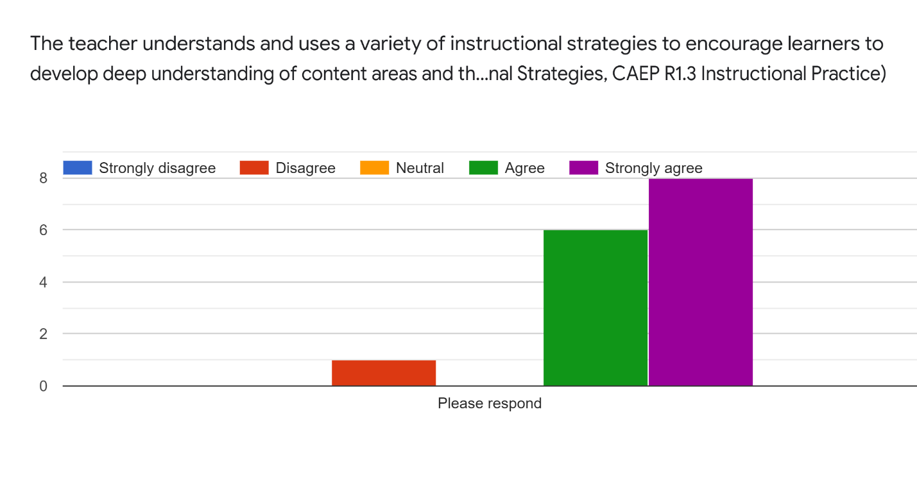

Fall 2020
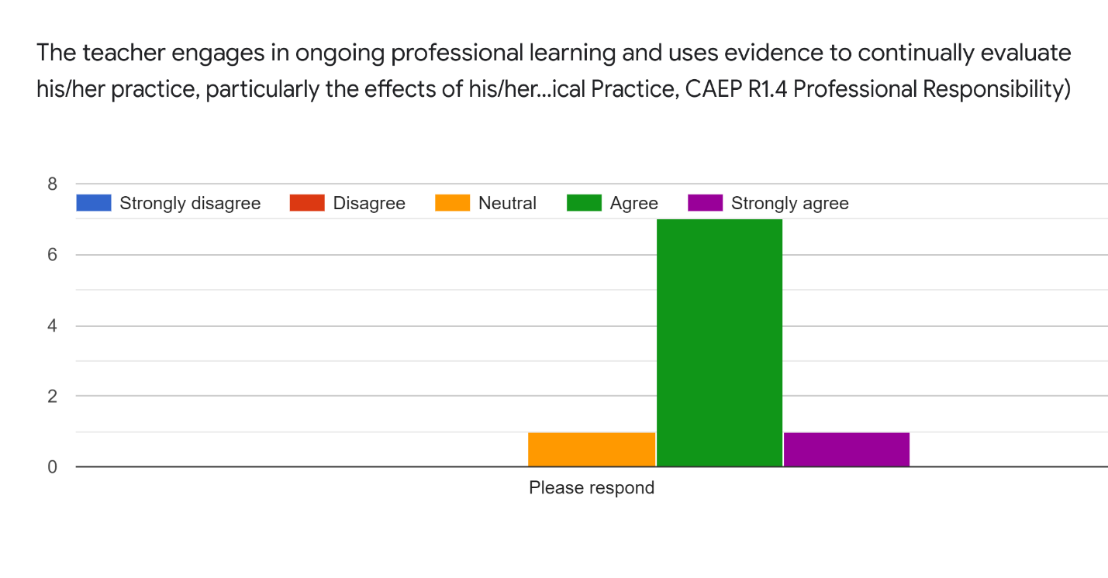Spring 2021
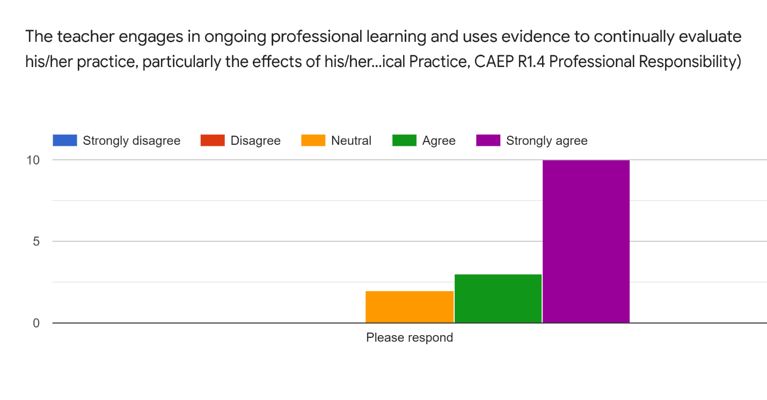

Fall 2020
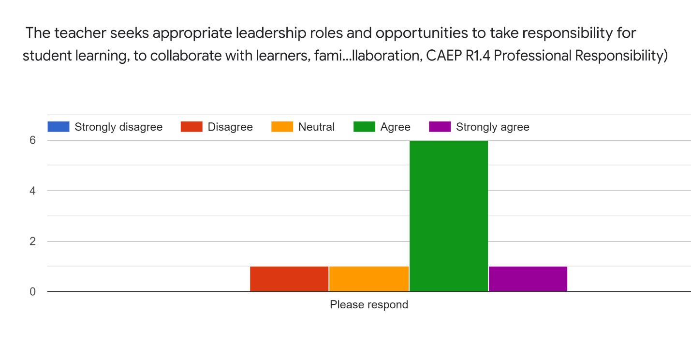
Spring 2021
