Nicholls Online

Course Design Template
(Revised November 2017)

The top section on Moodle must include the following:
- Course name and description
- Instructor contact information (must be visible or a single document)
- Start Here (Must be a visible stand-alone document)
  - Start Here document must include all important information to your course and to get the online student started in your course)
- Syllabus (Must be a visible stand-alone document; PDF is recommended)

Course must also include:
- Course must be broken down in separate sections that coincide with your lessons. These can be called modules, sections, chapters, weeks, etc.
- Visible due dates
  - Your course should have one main document that lists all of the due dates for the class and/or have due dates clearly listed under each module
- Exams and assessments should be easy to find and distinguishable from other course content. These could be all in one “topic” or within each chapter/module.

(See below for two examples)

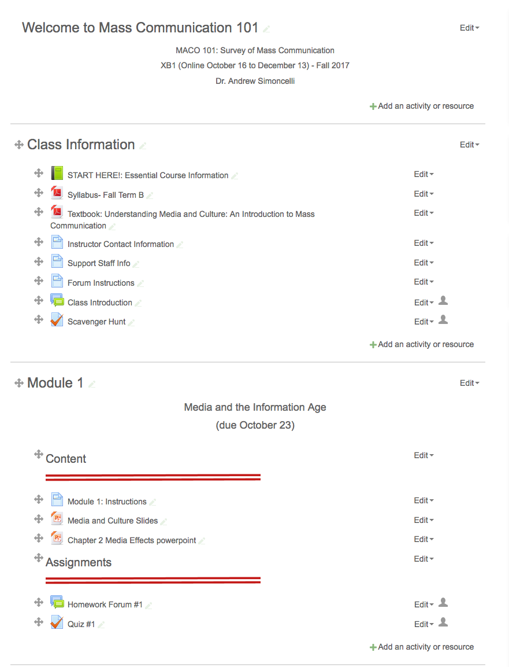
Example 1:
Top of Page with first sections: Class Information and Module 1
Includes Introduction and Scavenger Hunt. Assessments fall under each Module and are separated by lines.

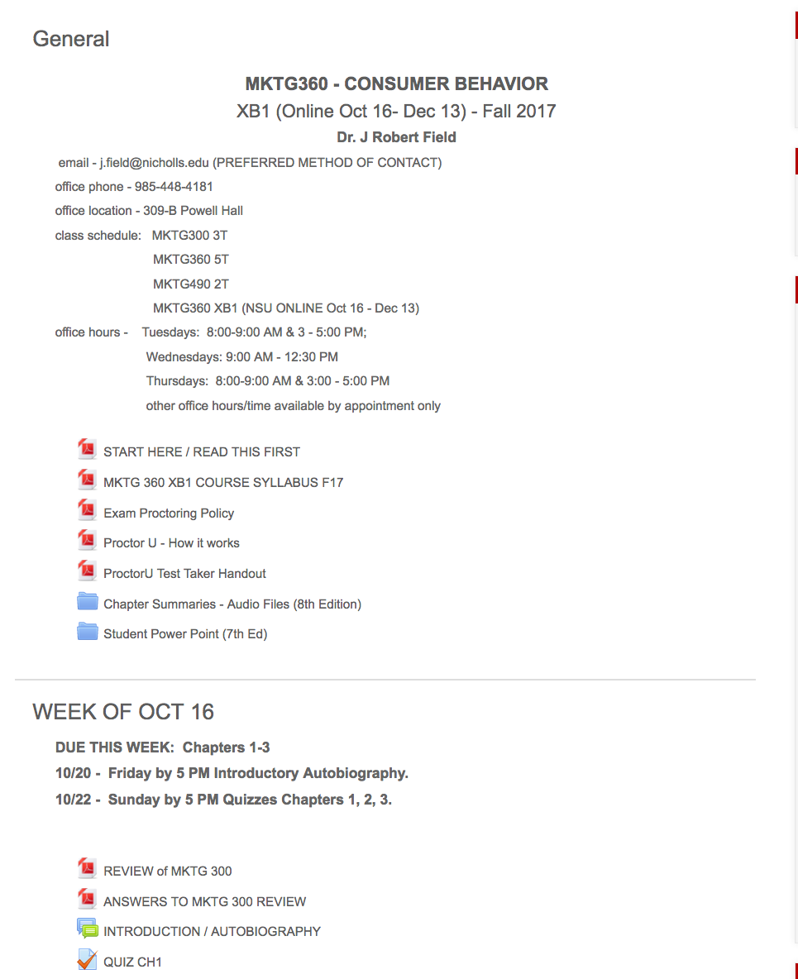
Example 2a:
Top of page with first sections: Class Information and Week 1.
Instructor information is all listed on main page and not in document.
Important policies are pulled out of syllabus and included on main page.

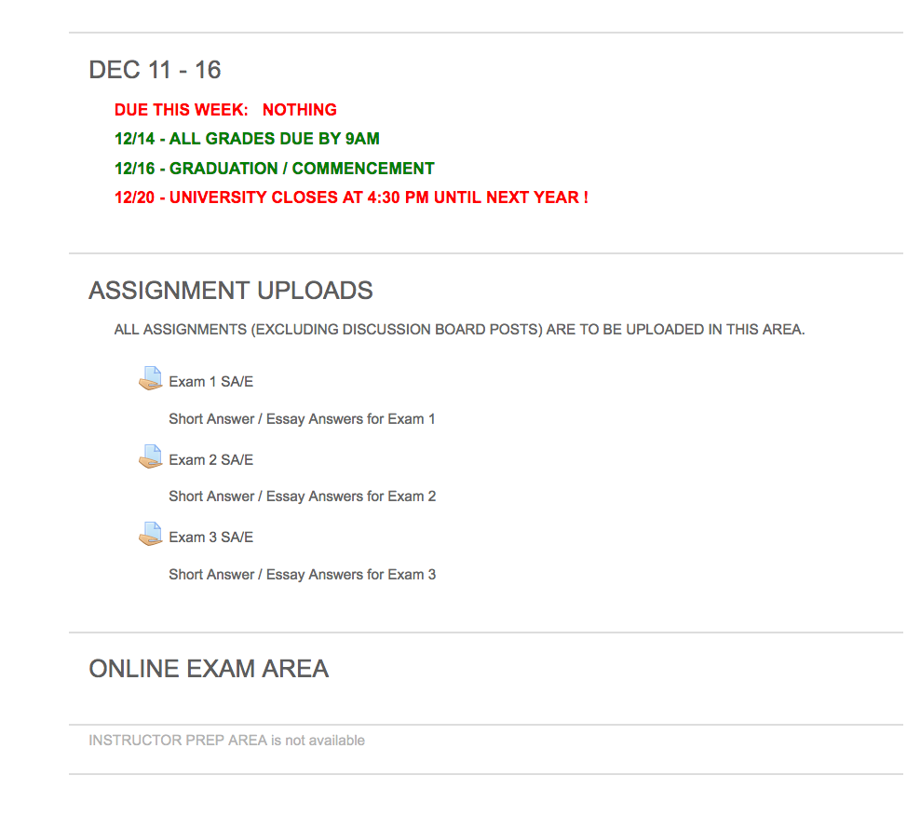
Example 2b Assessments.
Example 2b has a section dedicated to Assignment Uploads; while Example 1 included the Assessments within each module. Both are acceptable as long as they sections are clear and include due dates.

