**University of Louisiana Board of Supervisors Members**

[[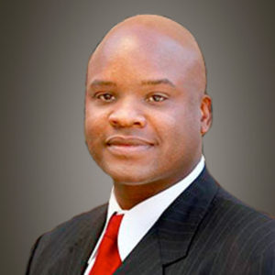](https://www.ulsystem.edu/board-members/#tm_2)](https://www.ulsystem.edu/board-members/" \l "tm_2)

[James Carter, Esq.](https://www.ulsystem.edu/board-members/" \l "tm_2)

[Chair](https://www.ulsystem.edu/board-members/" \l "tm_2)

[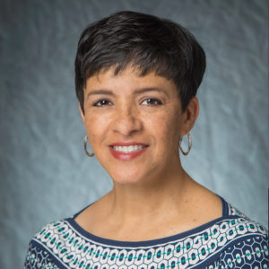](https://www.ulsystem.edu/board-members/" \l "tm_4)

[Elizabeth Pierre](https://www.ulsystem.edu/board-members/" \l "tm_4)

[Vice Chair](https://www.ulsystem.edu/board-members/" \l "tm_4)



Jimmy Clarke

Parliamentarian

[](https://www.ulsystem.edu/board-members/#tm_4)

John Condos

[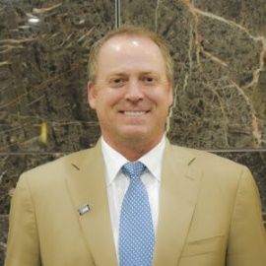](https://www.ulsystem.edu/board-members/" \l "tm_5)

[Steve Davison](https://www.ulsystem.edu/board-members/" \l "tm_5)

[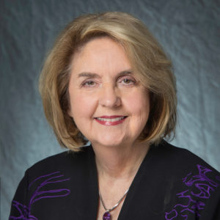](https://www.ulsystem.edu/board-members/#tm_6)

[Lola Dunahoe](https://www.ulsystem.edu/board-members/" \l "tm_6)

[[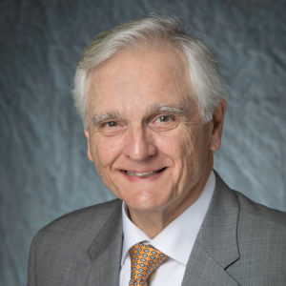](https://www.ulsystem.edu/board-members/#tm_8)](https://www.ulsystem.edu/board-members/" \l "tm_8)

[Thomas Kitchen](https://www.ulsystem.edu/board-members/" \l "tm_8)

[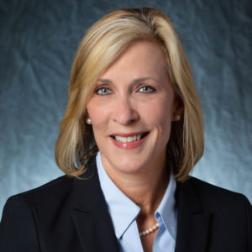](https://www.ulsystem.edu/board-members/" \l "tm_9)

[Mimi Methvin](https://www.ulsystem.edu/board-members/" \l "tm_9)

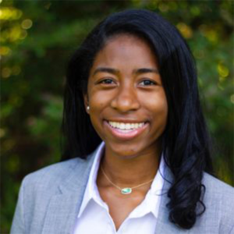

L’Oreal Williams

Student Board Member

[[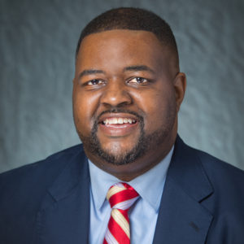](https://www.ulsystem.edu/board-members/#tm_12)](https://www.ulsystem.edu/board-members/" \l "tm_12)

[Alejandro "Al" Perkins](https://www.ulsystem.edu/board-members/" \l "tm_12)

[[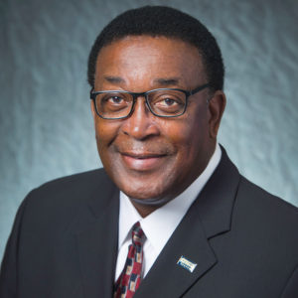](https://www.ulsystem.edu/board-members/#tm_14)](https://www.ulsystem.edu/board-members/" \l "tm_14)

[Virgil Robinson](https://www.ulsystem.edu/board-members/" \l "tm_14)

[.](https://www.ulsystem.edu/board-members/" \l "tm_14)

[[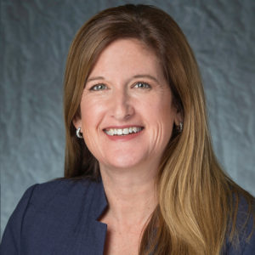](https://www.ulsystem.edu/board-members/#tm_15)](https://www.ulsystem.edu/board-members/" \l "tm_15)

[Kristine Russell](https://www.ulsystem.edu/board-members/" \l "tm_15)

[[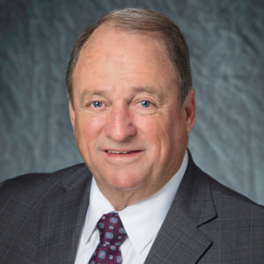](https://www.ulsystem.edu/board-members/#tm_16)](https://www.ulsystem.edu/board-members/" \l "tm_16)

[Joe Salter](https://www.ulsystem.edu/board-members/" \l "tm_16)

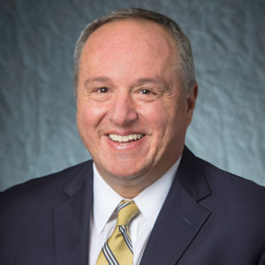

Mark Romero



Brad Stevens



Barry Busada