**University of Louisiana Board of Supervisors Members**

[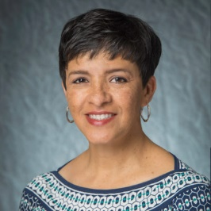](https://www.ulsystem.edu/board-members/" \l "tm_2)

[Elizabeth Pierre](https://www.ulsystem.edu/board-members/" \l "tm_2)

[Chair](https://www.ulsystem.edu/board-members/" \l "tm_2)

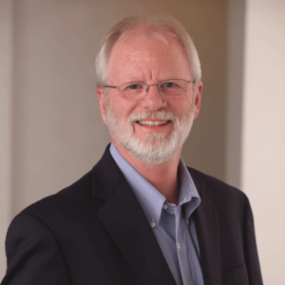

Jimmy Clarke

Vice Chair

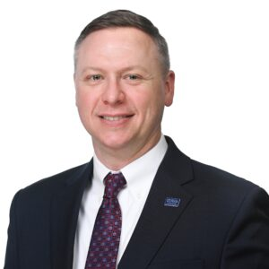

Brad Stevens

Parliamentarian

[](https://www.ulsystem.edu/board-members/#tm_4)

John Condos

[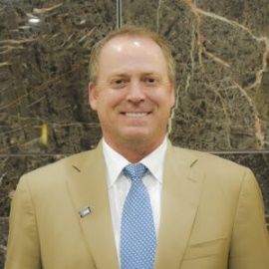](https://www.ulsystem.edu/board-members/" \l "tm_5)

[Steve Davison](https://www.ulsystem.edu/board-members/" \l "tm_5)

[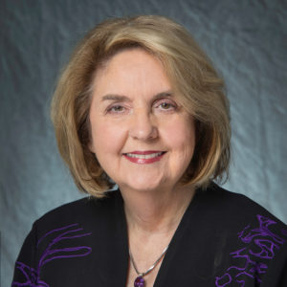](https://www.ulsystem.edu/board-members/#tm_6)

[Lola Dunahoe](https://www.ulsystem.edu/board-members/" \l "tm_6)

[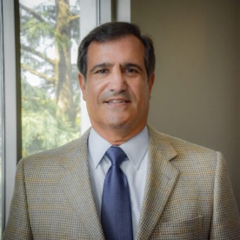](https://www.ulsystem.edu/board-members/" \l "tm_8)

[Barry Busada](https://www.ulsystem.edu/board-members/" \l "tm_8)

[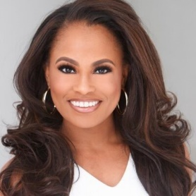](https://www.ulsystem.edu/board-members/" \l "tm_9)

[Jo’Quishia Lethermon](https://www.ulsystem.edu/board-members/" \l "tm_9)



Dana Peterson

[[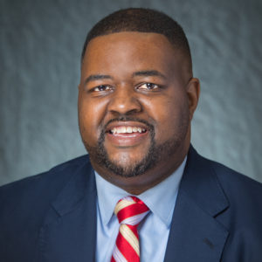](https://www.ulsystem.edu/board-members/#tm_12)](https://www.ulsystem.edu/board-members/" \l "tm_12)

[Alejandro "Al" Perkins](https://www.ulsystem.edu/board-members/" \l "tm_12)

[[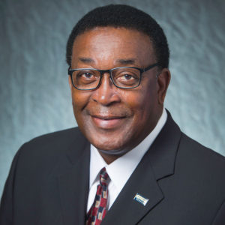](https://www.ulsystem.edu/board-members/#tm_14)](https://www.ulsystem.edu/board-members/" \l "tm_14)

[Virgil Robinson](https://www.ulsystem.edu/board-members/" \l "tm_14)

[.](https://www.ulsystem.edu/board-members/" \l "tm_14)

[[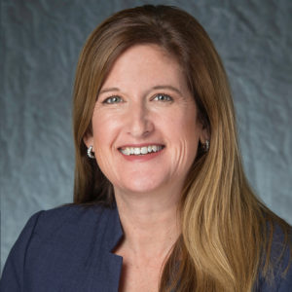](https://www.ulsystem.edu/board-members/#tm_15)](https://www.ulsystem.edu/board-members/" \l "tm_15)

[Kristine Russell](https://www.ulsystem.edu/board-members/" \l "tm_15)

[[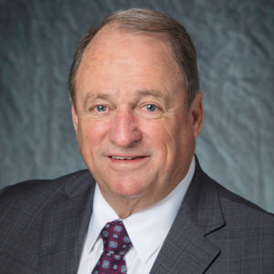](https://www.ulsystem.edu/board-members/#tm_16)](https://www.ulsystem.edu/board-members/" \l "tm_16)

[Joe Salter](https://www.ulsystem.edu/board-members/" \l "tm_16)

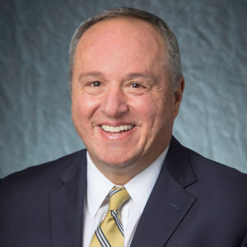

Mark Romero

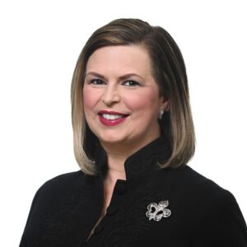

Julie Stokes

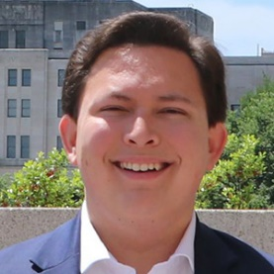

Ethan Estis

Student Board Member