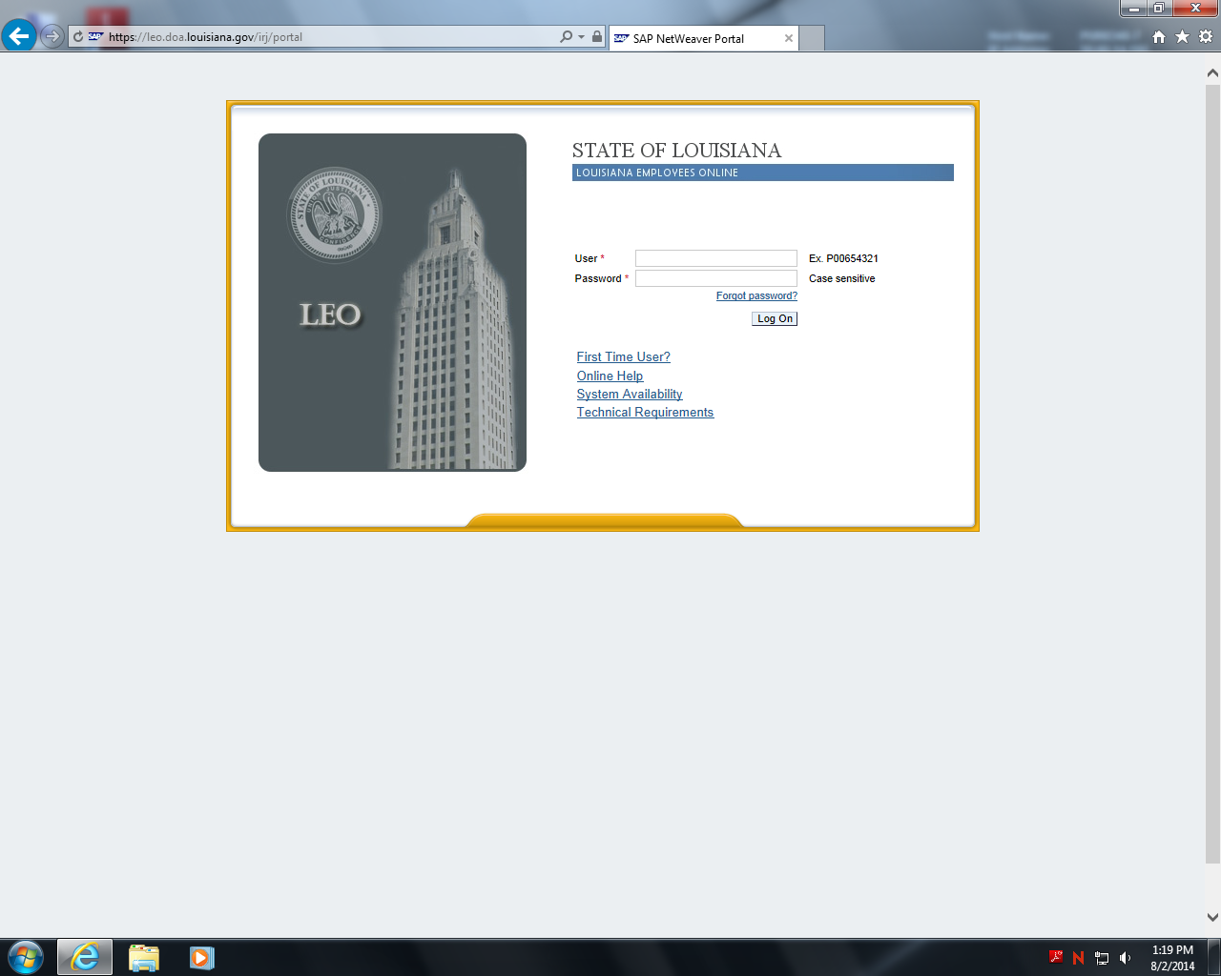

Enter H Number and Password on this page

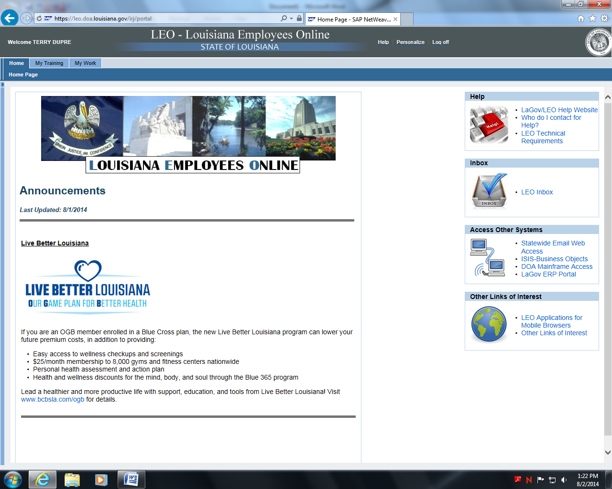

Click on My Training Tab

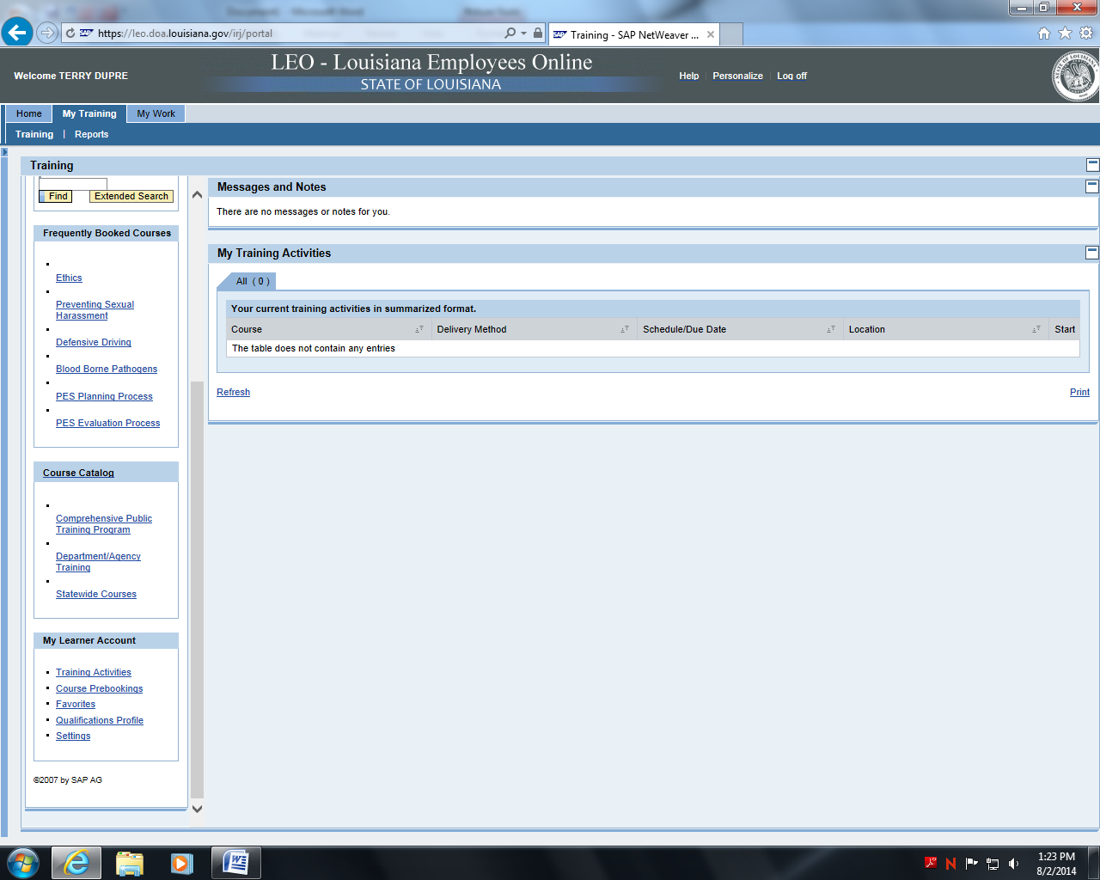

Click on Statewide Courses

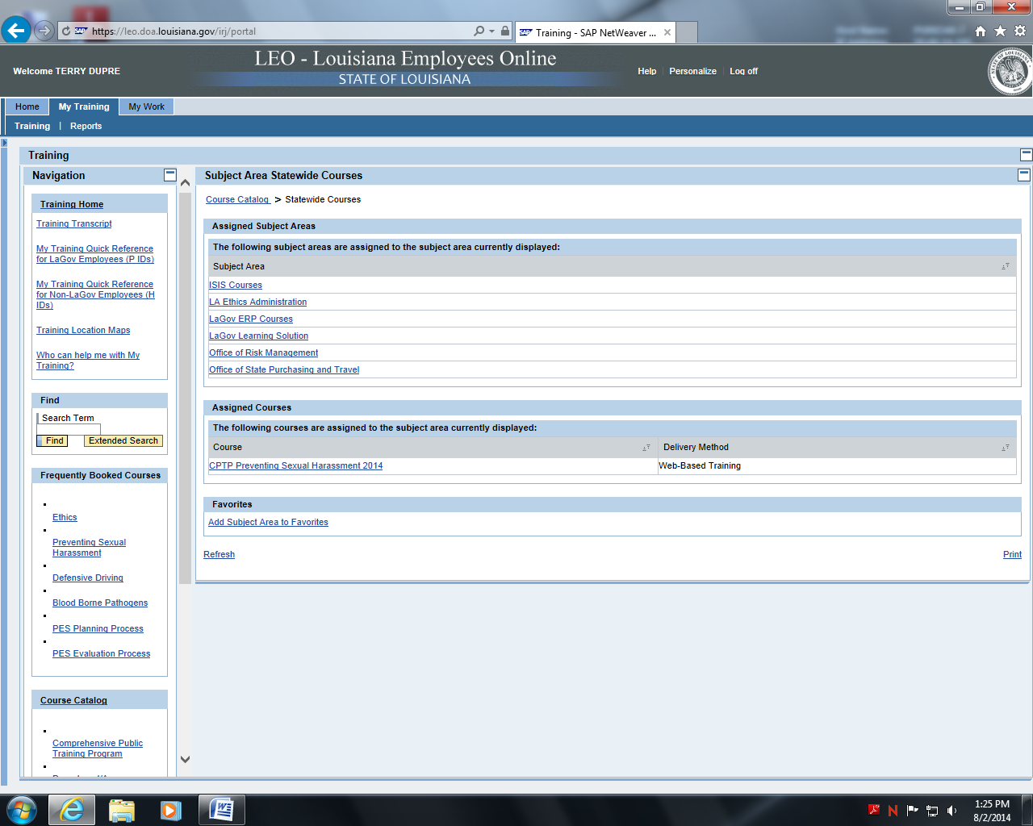

Click on Office of State Purchasing and Travel

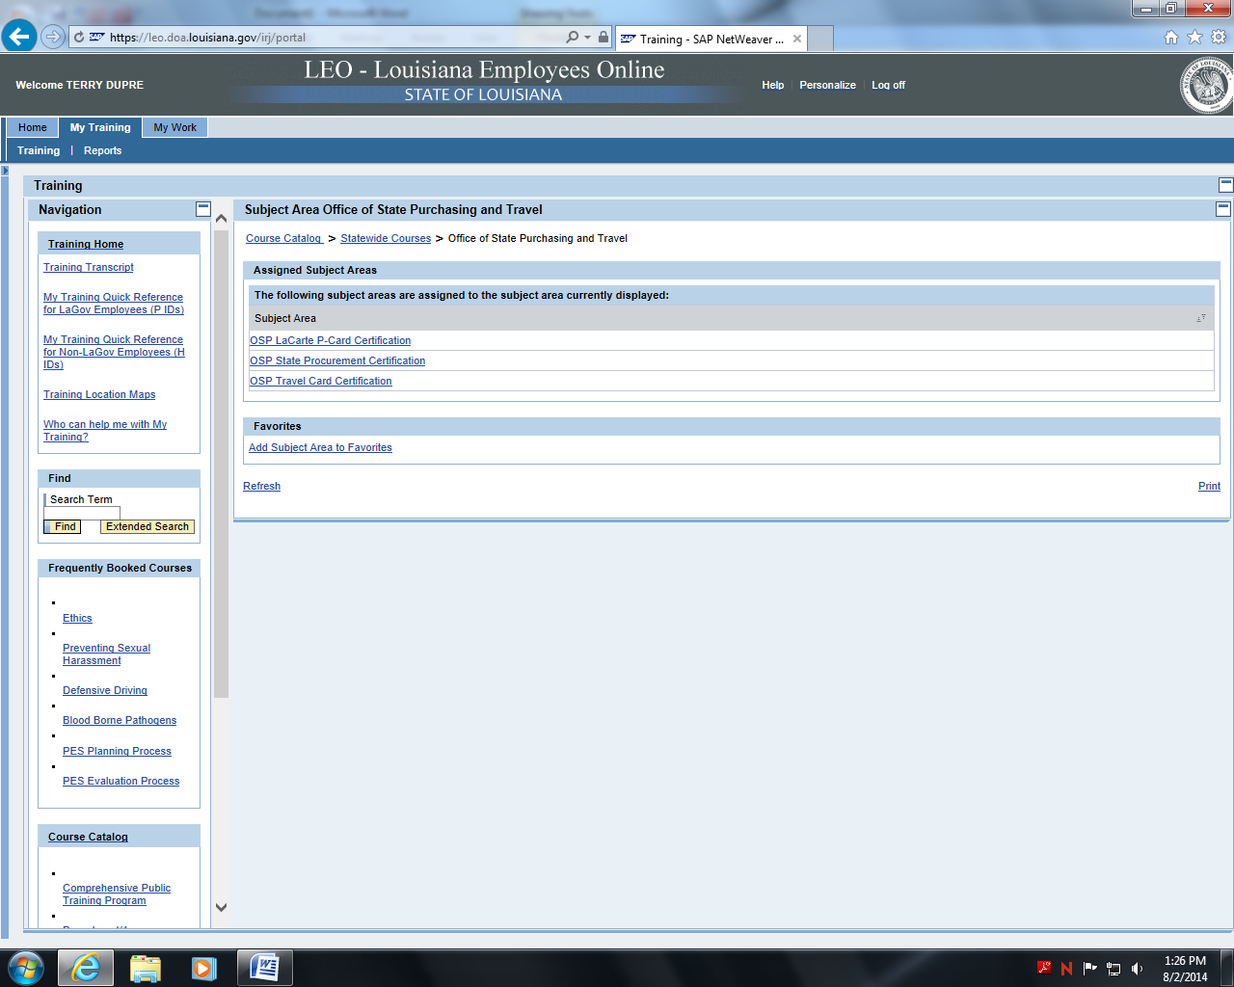

Click on OSP LaCarte P-Card Certification

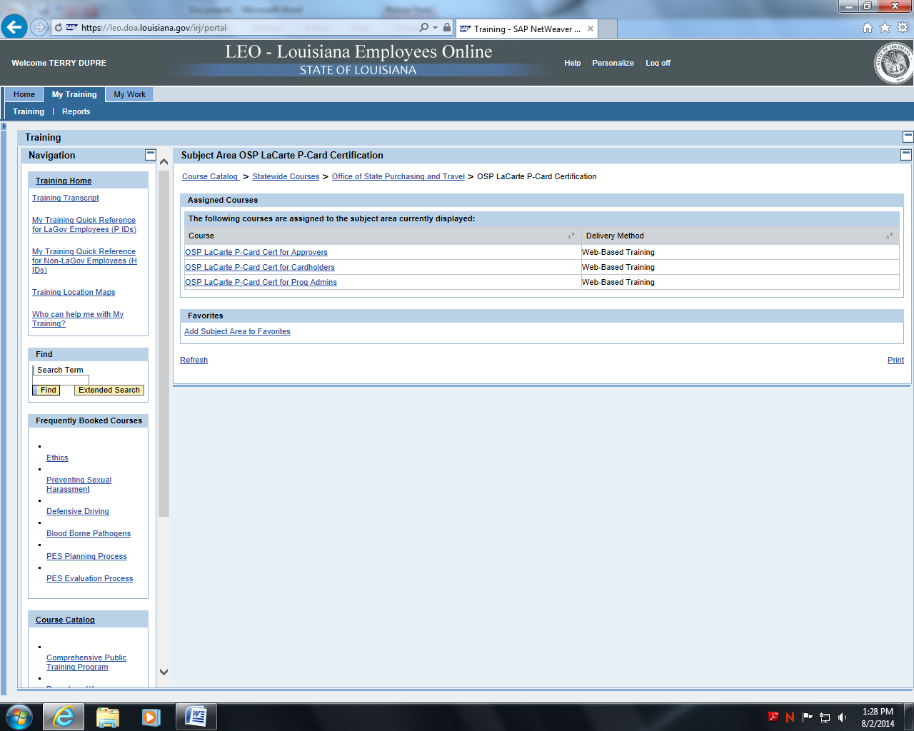

Click on the training for your role in the P-Card Program

If you are an approver – Click OSP-LaCarte P-Car Cert for Approvers

If you are a card holder – Click OSP LaCarte P-Card Cert for Cardholders

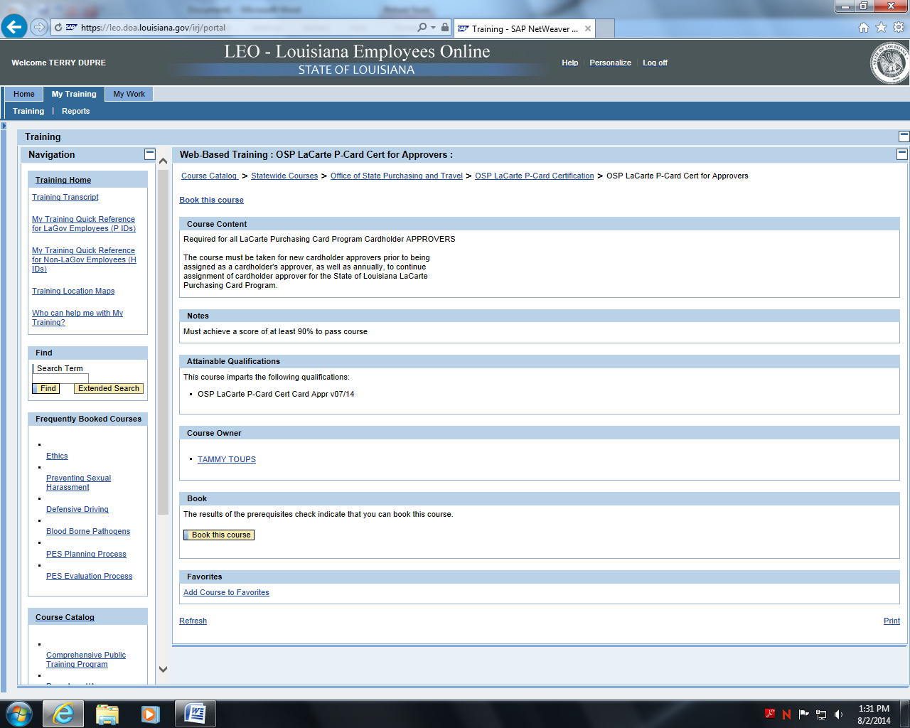

Click Book this course. Sample shown for approver training. Cardholder training would be the same at this step

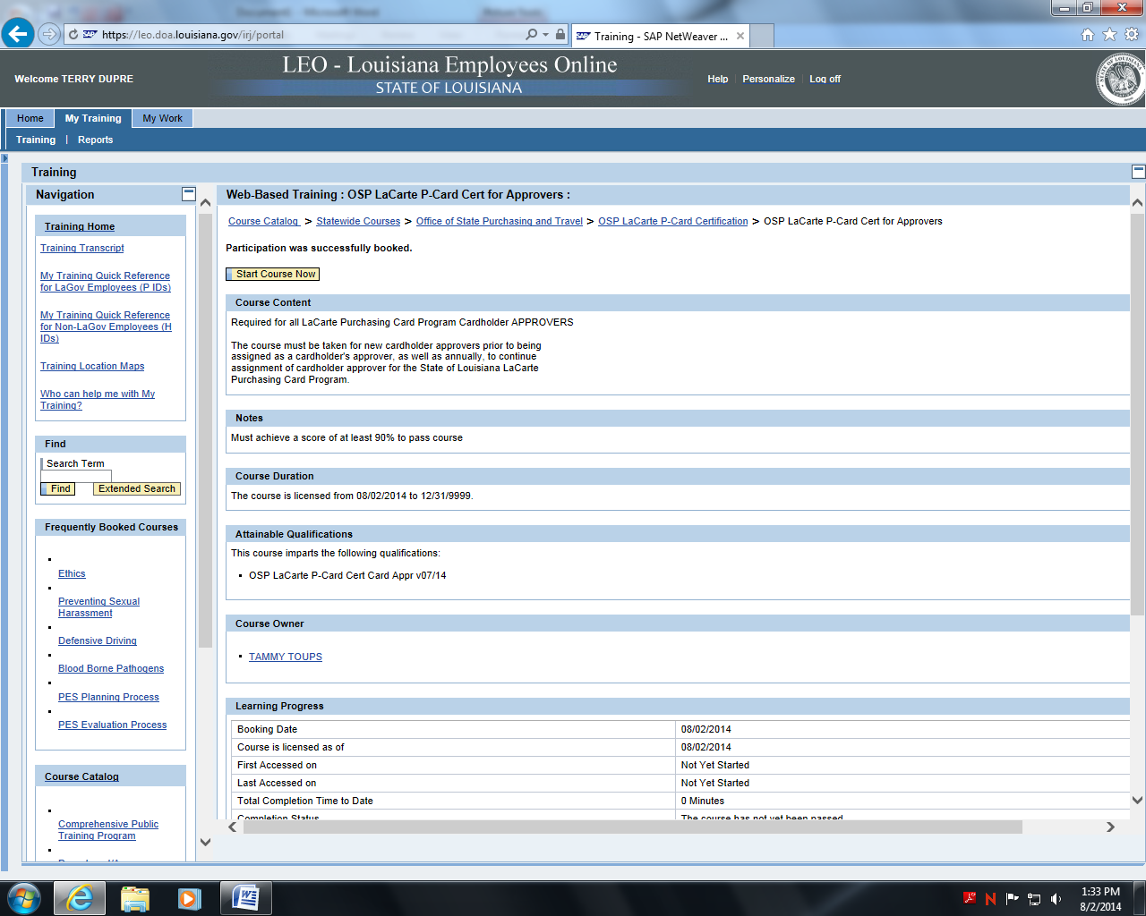

At completion of course – Please print the last page with your score and retain a copy for your p-card file, and send a copy to Purchasing. Should you have any trouble with the course, please contact Purchasing at ext. 4031 or ext. 4037 so that Purchasing may assist you.

Thank you for your efforts.

Click Start Course Now