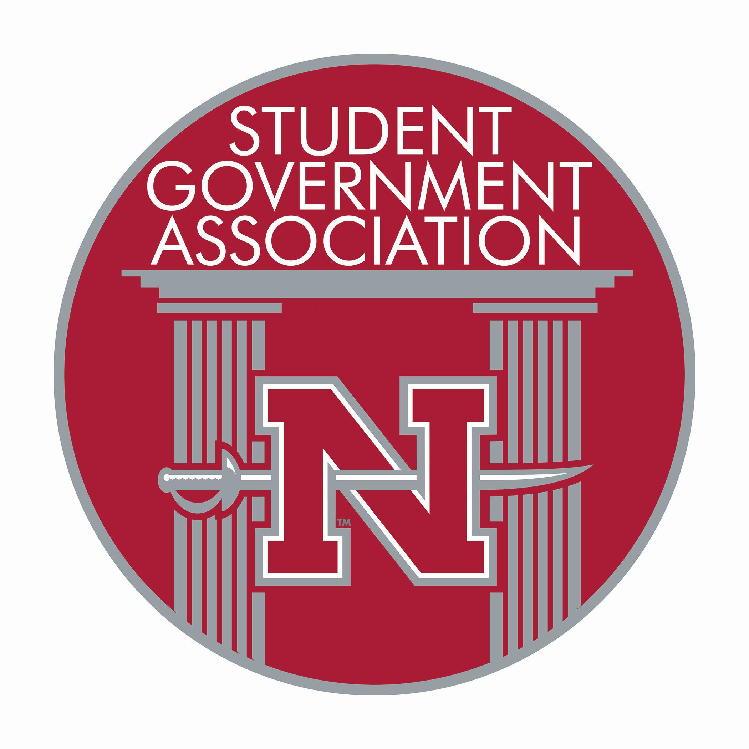

CODE OF ETHICS

STUDENT GOVERNMENT ASSOCIATION

NICHOLLS STATE UNIVERSITY

P.O. Box 2049

Thibodaux, Louisiana 70310
(985) 448-4557

Officers:
Jax Badeaux Student Body President
Douglas Gilchrist Student Body Vice President
John Schaefer Treasurer
Andrew B. Naquin Director, Student Rights & Grievances
Kyleigh Baudry Director, Public Relations
Dolly McGeever Secretary

Term of office for all Executive Board Members except Secretary shall be May 15, 2024, through May 14, 2025.

Cover updated 5/15/24

Code of Ethics for Student Government Officials
Revised: August 24, 2020

Article I
Purpose

We, officials of the Nicholls State University Student Government Association, in our continual efforts for the betterment of our school and student body, decided to enact a code of conduct upon ourselves. We believe a code of conduct will help in guiding us to uphold the principles and standards that being SGA officials demand. It is our hope that this document, the Code of Ethics, will bring us closer to our goal of serving, representing, and unifying the Nicholls community.

Article II

Organization

Section One
The Code of Ethics consists of five main sections: Purpose, Organization, Principles, Guidelines, and Use of the Code. The Purpose explains why we, SGA officials feel that it is important to have a Code of Ethics. Organization gives a listing of the various sections of the Code of Ethics. Ethical and moral guidelines are described in the Principles section, while the Guidelines section explains general guidelines to be followed by an SGA official in meetings or other SGA business. Lastly, the Use of the Code explains how the code should be used and in which situations.

Section Two
Definitions: The Code of Ethics uses various terms throughout the document that are explained in this section for clarification.
- Nicholls Community: Includes the students, faculty, support staff, and administration at Nicholls State University.
- Moral: Applies to the goodness of personal character and behavior.
- Ethical: Stresses the idealistic standards of right and wrong.
- Student Government Association official: Refers to executive, legislative, and judicial officials of the Student Government Association.

Article III

Principles

Section One
Public service is a public trust. It is the SGA official's responsibility that the Nicholls community has complete confidence in the integrity of their representative leaders.

Section Two
SGA officials pledge to uphold the SGA Constitution, Rules and Procedures, and Nicholls State University Student Code of Conduct.

Section Three
SGA officials pledge to perform duties efficiently and with the best of thought.

Section Four
SGA officials pledge to never discriminate by giving one group or person special favors.

Section Five
SGA officials pledge to make no private promises or have any private agendas since they are working for what is in the best interests of the Nicholls community.

Section Six
SGA officials pledge to be of good repute at all times because they represent the standards of the Nicholls community.

Section Seven
SGA officials pledge to expose corruption wherever found.

Article IV
Guidelines

Section One

Code of Official Conduct
- General Meetings
    - SGA officials pledge to come to meetings knowledgeable of the matters at hand so that they can best serve the Nicholls community.
    - SGA officials pledge to be responsible for learning the basic parliamentary procedures listed in Robert's Rules of Order.
    - SGA officials pledge to conduct themselves in a professional manner always realizing that they are the embodiment of the morals and standards of the Nicholls community.
    - SGA officials pledge to conduct only public business at general meetings. Meetings are not a forum to discuss private and personal matters.
    - SGA officials pledge not to use the meetings as a platform to propel themselves favorably into the public's eye but to earn public favor through good work.
    - SGA officials pledge to prohibit all communiqués—notes not pertaining to official business, phones, talking—from the meeting.
    - SGA officials pledge not to use the meeting to endorse an event that would be deemed disreputable, immoral, or unethical in the eyes of the Nicholls community.
- Committees
    - SGA officials pledge to abide by all guidelines listed in General Meeting Guidelines (Article 4, Section 1) of the Code of Ethics.
    - SGA officials pledge to present to the Senate a detailed report of the minutes of the meeting.
    - SGA officials pledge to act in the best interests of the students.
    - SGA officials pledge not to reveal any confidential information discussed in the committee, including but not limited to, the discussion of nominees, appointments, and interviews (including questions asked).
    - SGA officials pledge to move to table all motions that come up on behalf of the students where either they are not knowledgeable of in the matter or where student consent is needed.
    - SGA officials pledge to attend all University committee meetings dutifully, always remembering that they are the student voice on these committees and are the liaison between the faculty and student body.

Section Two

Code of Conduct in the Public's Eye
- SGA officials pledge to remember to conduct themselves in a moral and ethical manner when acting as an SGA official at campus events and on private time when wearing an SGA logo.
- SGA officials pledge to act with decency.
C. SGA officials pledge to keep all internal affairs of the SGA within the SGA.

Article V
Use of the Code

Section One
SGA officials pledge to encourage their colleagues to adhere to the Code of Ethics, holding each other accountable while striving to follow the Code of Ethics themselves.

Section Two
SGA officials will pledge to the Code of Ethics before their installation as an SGA official.

Section Three
SGA officials pledge to read the Code of Ethics or any section of the document when they feel that the Senate needs to be reminded of their moral and ethical obligation to the Nicholls community.

Section Four

Discipline
- The Code of Ethics Disciplinary Committee shall be chaired by the SGA Vice President, and the members shall consist of a representative from each SGA standing committee chosen by lot.
- An SGA official alleged to be in violation of the Code of Ethics shall be brought before the Code of Ethics Disciplinary Committee.
- The Code of Ethics Disciplinary Committee is given all rights and privileges for disciplinary action of an SGA official in violation of the Code of Ethics.
D. Reporting an SGA Official
  - Any fee-paying student and/or SGA officials can report someone in violation of the Code of Ethics.
  - An incident report that includes the name, date, time, location, and a detailed account of the incident must be completed fourteen days after the alleged incident and turned into the Vice President.

Section Five

Powers of the Code of Ethics Disciplinary Committee
- No SGA official shall be automatically removed for any violation of the Code of Ethics.
- The Code of Ethics Disciplinary Committee is limited to dispensing one of the following disciplinary actions (listed in ascending order of seriousness):
1. Reprimand: SGA official is told that he or she has violated their covenant to uphold the principles of the Code of Ethics. A reprimand is placed in the official's file, and he or she must once again pledge to the Code of Ethics.
2. Censure: In occurrences where the SGA official is deemed a threat to the moral and ethical public image of the SGA or the Nicholls community, he or she can be temporarily or permanently removed from a position (committee head, committee member, etc.) to one where he or she can do no harm.
Note: This is not meant to remove the SGA official from the SGA or to replace an impeachment.
3. Removal from the Executive Board, Senate, Supreme Court, or Election Commission: Must follow the guidelines for removal stated in the Nicholls State University SGA Constitution (Article III, Section 3, G).
- Amending the Code: Shall follow the same amendment process as amendments to Rules and Procedures.

