

STUDENT MANUAL
INTRODUCTION
This manual was developed by Nicholls State University Student Employment Office to assist student employees at the University in understanding and becoming proficient with web time entry as a time keeping method. It is revised periodically to include helpful information for the campus as it becomes available.
Web time entry is the time keeping method for most student employees at Nicholls State University. Students will be responsible for entering and submitting their hours every pay period. The supervisor will then be responsible for approving the time sheet. Once the hours have been approved, the time sheet will then be processed by the Student Employment Office.
While this information is intended to be a tool to increase the student employees’ understanding of the various features of web time entry it is no way intended to address unique situations and/or questions concerning web time entry. For this purpose, student employees are encouraged to contact any member of the Student Employment Office staff for assistance.
If you have any questions concerning web time entry, please feel free to contact with Rachel Babin at (985)449-7176 or Cathy Arcement at (985)448-4043.
Student Employment Office
Otto Candies Hall
Phone: (985) 448-4043
Fax: (985) 448-4124
Hours: 8:00 am to 4:30 pm
Monday through Friday

TABLE OF CONTENTS

Logging into Banner Self Service 3
Accessing Your Time Sheet 3
Entering Time 5
Copying Hours 7
Entering Comments 8
Previewing Time Sheet 9
Submitting Time for Approval 10
Return Time 11
Logging Out 12

LOGGING INTO BANNER SELF SERVICE
- Navigate to www.nicholls.edu/finaid/student-employment
- Select ‘Click here for Web Time Entry and Check Stubs’ on the right side of the page.
- Choose ‘Enter Secure Area’.
- Enter User ID (campus ID number) and PIN.
  - Contact Student Employment at (985)448-4043 if you have forgotten your PIN.
  - If this is the first time you have logged in to Employee Self Service, a Login Verification Security Question and Answer screen will appear. This allows the user to enter a question and answer to remember, so if your PIN is forgotten, you may click the Forgot PIN button on the previous page.
- Once logged in to Banner Self Service, choose ‘Employee Services’.
- From the Employee Services menu, select ‘Time Sheet’.

Use the navigation buttons included on the webpage. DO NOT use the back/forward buttons.

ACCESSING YOUR TIME SHEET

- Select the appropriate Title and Department by clicking the circle in the My Choice column.
- Select the Pay Period and Status from the pull down menu.
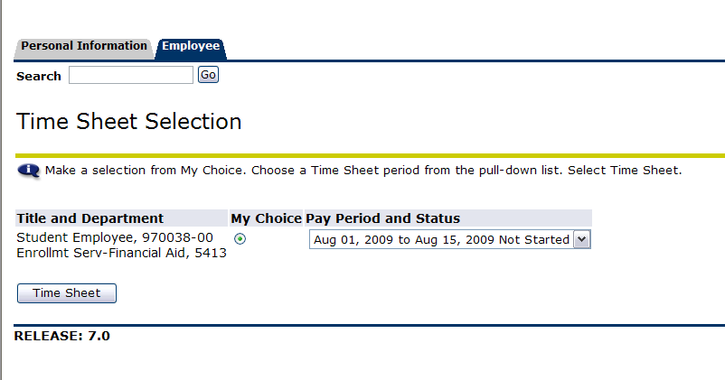

** Note: Status definitions
Not Started: The time sheet has not been initiated (not opened yet) by the employee. Once the employee selects the time sheet for a particular period and opens it, the status of the time sheets will change to “In Progress”.

In Progress: The time sheet has been initiated by the employee but is not completed and has not been submitted for approval.

Pending: The time sheet has been completed and submitted for approval by the employee. The record is waiting for the approver (usually the supervisor) to approve the time.

Approved: The time sheet has been approved and is ready to be submitted to the Student Employment Office.

Returned for Correction: The time sheet has been returned to the employee by the supervisor for correction.

- Click ‘Time Sheet’.

ENTERING TIME
- On the Time and Leave Reporting page, select ‘Enter Hours’ under the date in which time should be entered.
Note: Selecting the ‘Restart’ button on the Time In and Out page will wipe out
all information entered for the chosen pay period.
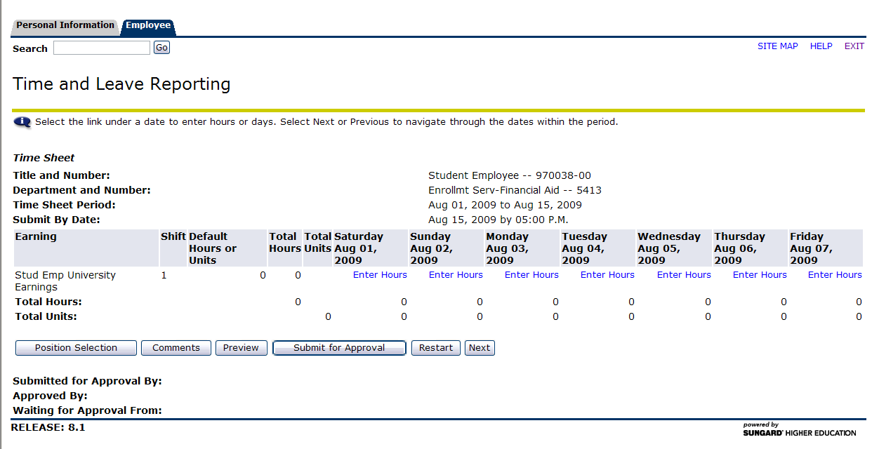

- On the Time In and Out page, enter the ‘Time In’ and ‘Time Out’ of the shift. Select AM or PM from the drop down boxes.
  - Minutes must be in intervals of 15 minutes (00, 15, 30, 45).
  - Multiple In/Out entries may be entered per day.
  - When working a full day that includes a break for lunch, please show time in/out before lunch and time in/out after lunch.
  - 12 Noon is PM and 12 Midnight is AM.
- Selecting the ‘Next Day’ option opens next calendar day available for time entry.
- Selecting the ‘Time Sheet’ option returns the user to the Time Sheet page.
- Select ‘Save’ to save the hours to the time sheet.

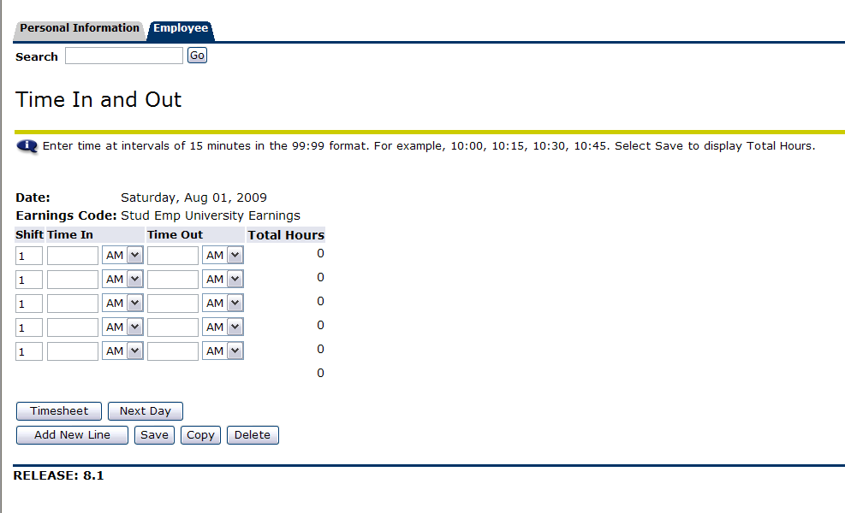

COPYING HOURS

Hours may be copied to other days in the pay period. This is useful if when working the same shift more than one time during the pay period.
- On the Time In and Out page, select ‘Copy’.
- On the Copy page, select the checkboxes for the days in which hours are to be copied.
- Note: Do not check off the day that you are copying from.
- Select ‘Copy’.
- Select ‘Time Sheet’ to return to the Time Sheet page.
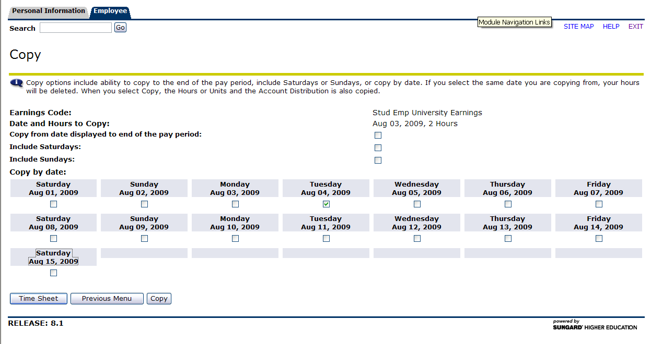

ENTERING COMMENTS
Comments should be entered before submitting time for approval. The supervisor may view these comments when approving a time sheet. An example of a comment is working during a scheduled class time because class has been cancelled.
- Select ‘Comment’ on the Time Sheet page.
- Type comment.
- Select ‘Save’ to return to Time Sheet page.
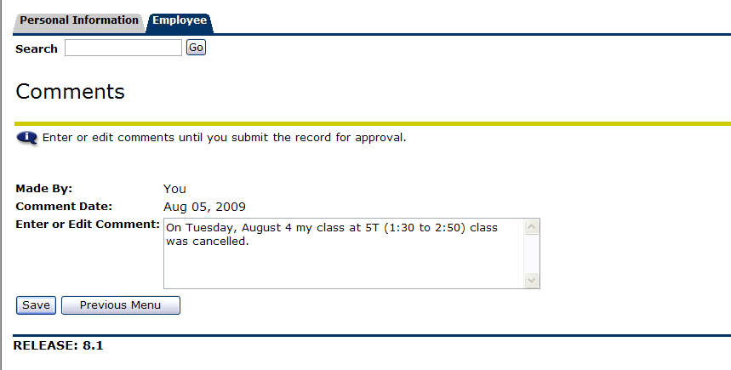

PREVIEWING TIME SHEET
The Preview option summarizes the information entered for the pay period. It is highly recommended that students preview their hours before a time sheet is submitted.
- Select ‘Preview’ on the Time Sheet page to review time that has been entered.
Note: If a supervisor requires this page be printed, set the print format to Landscape. The time sheet must still be submitted as explained in the next section regardless of if it was printed.
- Select ‘Previous Menu’ to return to Time Sheet page.
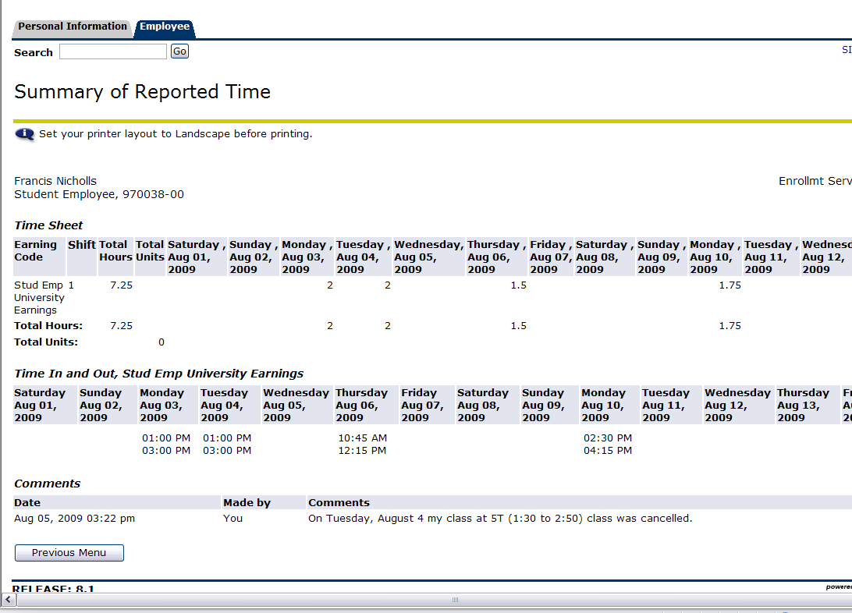

SUBMITTING TIME FOR APPROVAL

- Select ‘Submit for Approval’ on the Time Sheet page.
- Enter PIN and select ‘Submit’ to certify the information entered is correct.
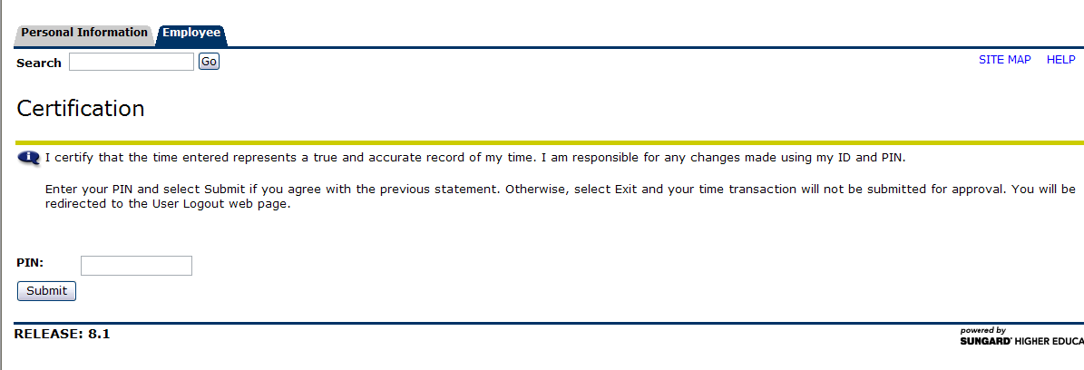
- Ensure message appears stating ‘Your time sheet was submitted successfully’.
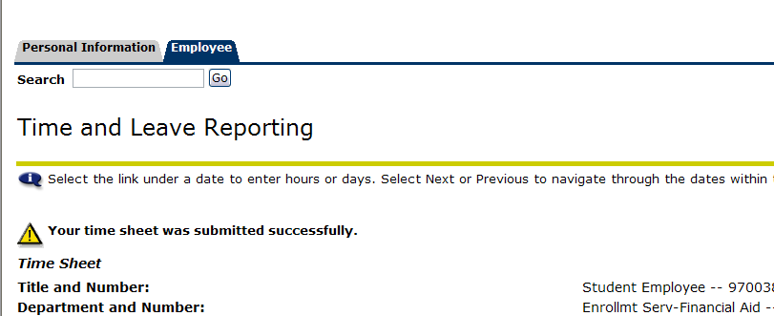

Once time is submitted, the status for the record on the Position Selection page is set to Pending. Changes to the time sheet cannot be made in this status. The time sheet has been sent to the supervisor for approval. Email your supervisor once the time sheet has been submitted for approval.

Time sheets must be submitted within one business day of the end of the pay period.

Hours should not be submitted until the end of the pay period. Once the time sheet is submitted changes cannot be made. Contact your supervisor if a change needs to be made.

Messages at the bottom of the Time and Leave Reporting page will indicate that the time sheet has been submitted and is waiting for approval by your supervisor. After the supervisor has approved the time, it will be indicated in the Approved By box.

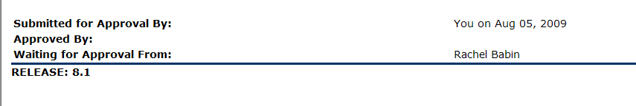

The status will change to Approved on the Time Sheet page once the supervisor has approved the time sheet. The time sheet is then sent to the Student Employment Office for processing.

Once the time sheet deadline has passed, the Submit for Approval button will not be available. If you failed to submit your time sheet before the deadline, hours should be recorded on the currently available time sheet. First, all hours from the previous time sheet should be entered on a date which you are not working during the current pay period. Secondly, in the comments section each date and in and out time from the previous pay period must be recorded.

RETURN TIME

If you need to make corrections to your time sheet after you have submitted it for approval, you may use the Return Time button. This button will be available after you have submitted your time until your supervisor approves your time sheet.

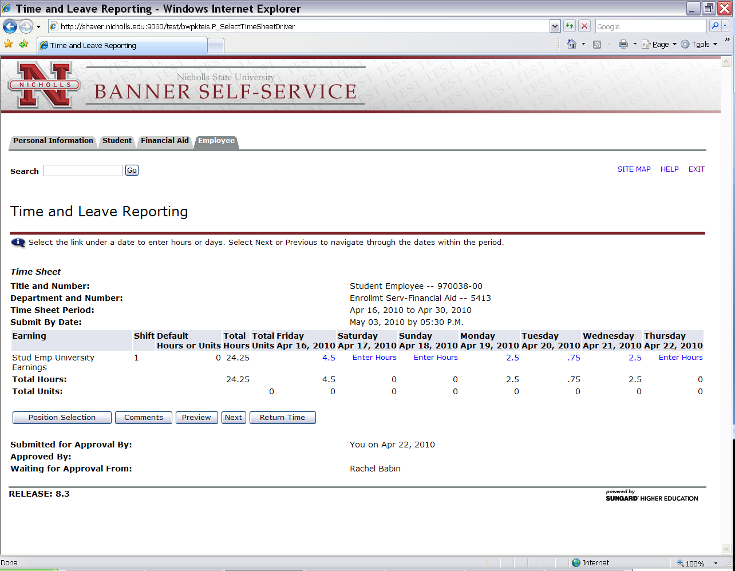

- Select ‘Return Time’ on the Time and Leave Reporting page.
- Make the necessary corrections to your time sheet.
- Select ‘Submit for Approval’ on the Time Sheet page.
- Enter PIN and select ‘Submit’ to certify the information entered is correct.
- Ensure message appears stating ‘Your time sheet was submitted successfully’.

LOGGING OUT
Select Exit in the upper right corner of the screen.

