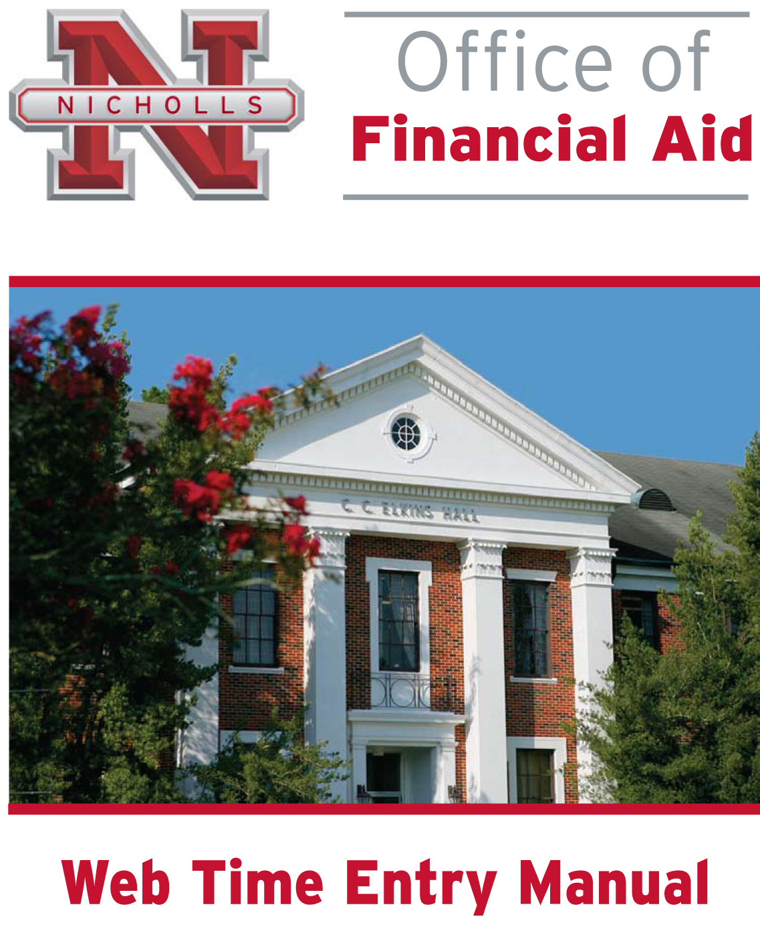

SUPERVISOR MANUAL
INTRODUCTION

This manual was developed by Nicholls State University Student Employment Office to assist student employee supervisors at the University in understanding and becoming proficient with the approvals of web time entry. It is revised periodically to include helpful information for the campus as it becomes available.
Web time entry is the time keeping method for most student employees at Nicholls State University. Students will be responsible for entering and submitting their hours every pay period. The supervisor will then be responsible for approving the time sheet. Once the hours have been approved, the time sheet will then be processed by the Student Employment Office. Submitting time for approval must occur by 5:00 p.m. one business day after the end of the pay period unless otherwise notified by the Student Employment Office. Approval should take place as soon as possible after this deadline.
Student employees’ time sheets will not appear in Employee Self Service until all appointment paperwork has been completed. Student employees should not begin working until supervisors receive the yellow copy of the student’s award letter. Request for Student Employee Authorization Forms should be sent up to two weeks prior to the student employee’s start date to ensure the student’s position is assigned in Banner when the student begins working.
While this information is intended to be a tool to increase the supervisors understanding of the various features of web time entry it is no way intended to address unique situations and/or questions concerning web time entry. For this purpose, supervisors are encouraged to contact any member of the Student Employment Office staff for assistance.
If you have any questions concerning web time entry, please feel free to contact with Rachel Babin at (985)449-7176 or Cathy Arcement at (985)448-4043.
Student Employment Office
Otto Candies Hall
Phone: (985) 448-4043
Fax: (985) 448-4124
Hours: 8:00 am to 4:30 pm
Monday through Friday

TABLE OF CONTENTS

Logging into Banner Self Service 3
Viewing Students’ Time Sheets 3
Returning a Time Sheet for Correction 8
Approving a Time Sheet 8
Return Time 9
Creating A Proxy 10
Logging Out 11

LOGGING INTO BANNER SELF SERVICE
- Navigate to www.nicholls.edu/finaid/student-employment
- Select ‘Click here for Web Time Entry and Check Stubs’ on the right side of the page.
- Choose ‘Enter Secure Area’.
- Enter User ID (campus ID number) and PIN.
  - Contact Student Employment at (985)448-4043 if you have forgotten your PIN.
  - If this is the first time you have logged in to Banner Self Service, a Login Verification Security Question and Answer screen will appear. This allows the user to enter a question and answer to remember, so if your PIN is forgotten, you may click the Forgot PIN button on the previous page.
- Once logged in to Banner Self Service, choose ‘Employee’.
- From the Employee Services menu, select ‘Time Sheet’.
Use the navigation buttons included on the webpage. DO NOT use the back/forward buttons.

VIEWING STUDENTS’ TIME SHEETS
It is recommended supervisors view the details of student employee time sheets before approving to ensure that hours were recorded correctly. Students may have recorded time on a day not scheduled or worked overtime in which you must alert the Student Employment Office, etc. By viewing the time sheet detail, supervisors will be able to make corrections to these types of mistakes.
Time must be recorded in intervals of 15 minutes (00, 15, 30, 45).
- Select ‘Approve or Acknowledge Time’ on the Selection Criteria page.
- Choose ‘Select’.
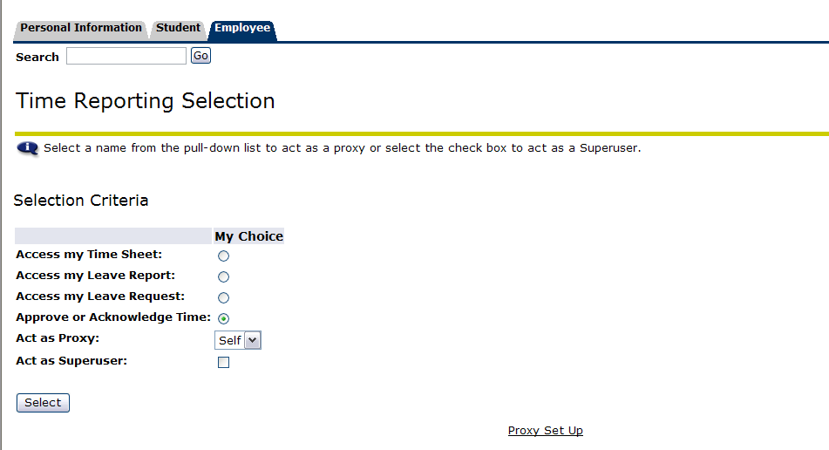
- Select the appropriate Department by clicking the circle in the My Choice column.
- Select the Pay Period from the pull down menu.
Note: The current pay period will only become an option after at least one student employee from the department has viewed his/her time sheet.
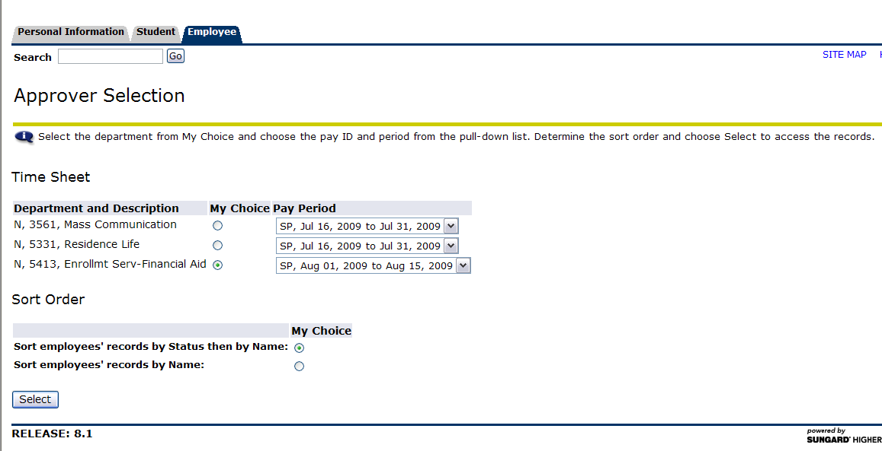
- Select the employee’s name and position on the Summary page to review an employee’s time.

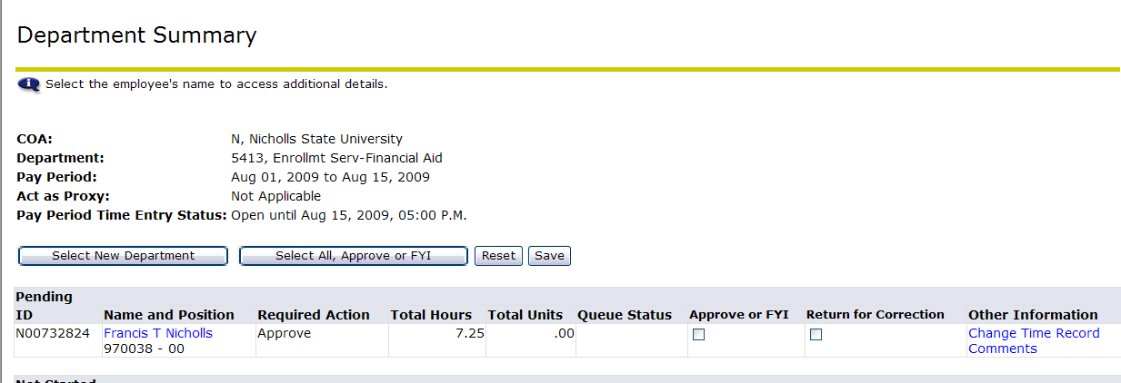

** Note: Status definitions
Not Started: The time sheet has not been initiated (not opened yet) by the employee. Once the employee selects the time sheet for a particular period and opens it, the status of the time sheets will change to “In Progress”.
In Progress: The time sheet has been initiated by the employee but is not completed and has not been submitted for approval.
Pending: The time sheet has been completed and submitted for approval by the employee. The record is waiting for the approver (usually the supervisor) to approve the time.
Approved: The time sheet has been approved and is ready to be submitted to the Student Employment Office.
Returned for Correction: The time sheet has been returned to the employee by the supervisor for correction.

CORRECTING A TIME SHEET
- Select ‘Change Record’ on the Employee Detailed Information page.
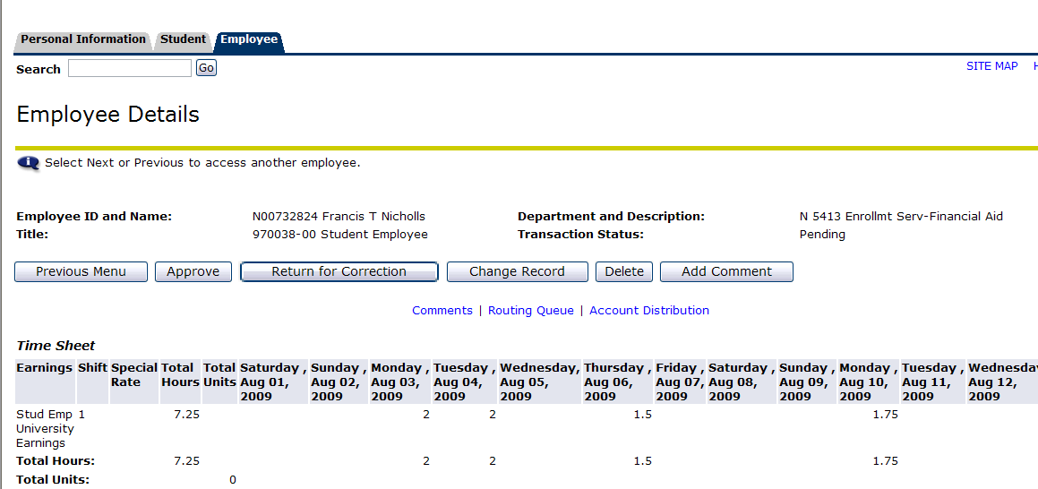

- Select the number on the day the change needs to be made.
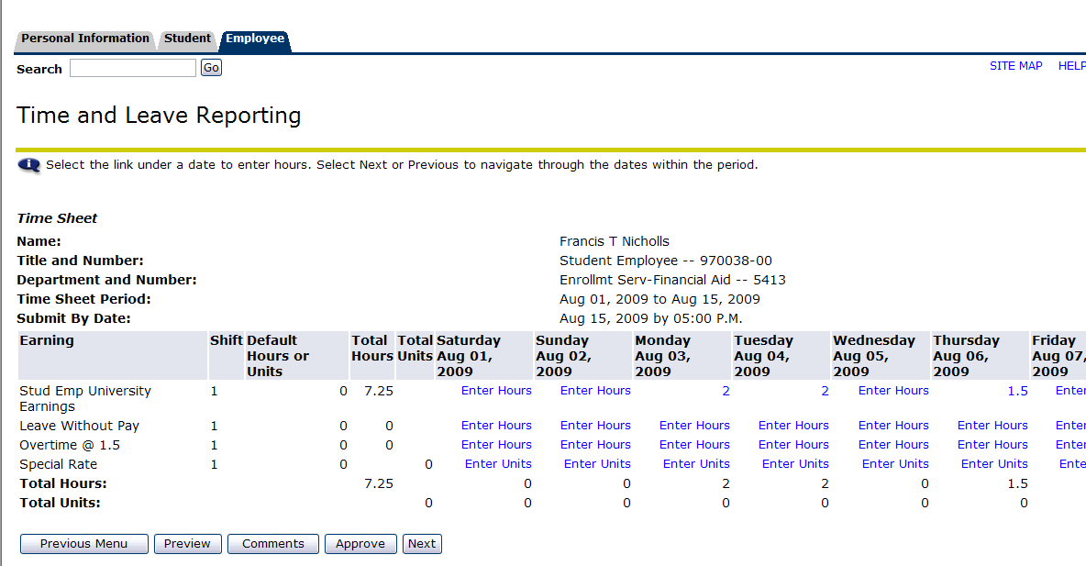
- Make corrections.
- Select ‘Save’.
Note: Overtime Pay can only be entered by a supervisor.
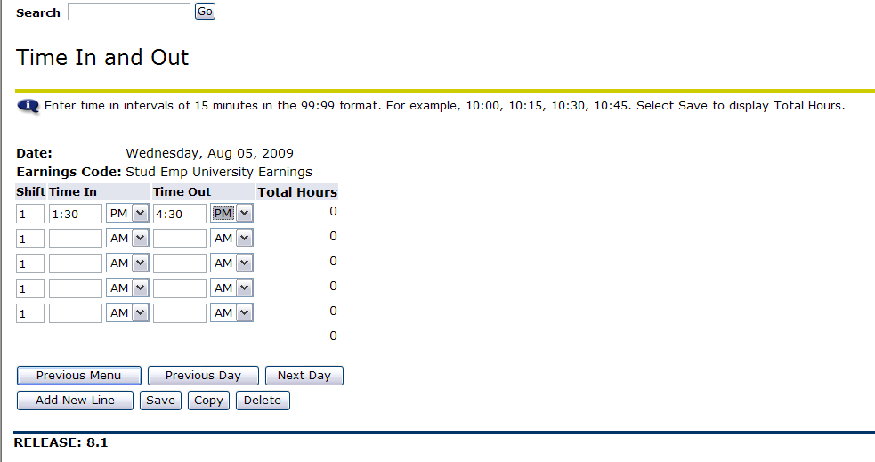

RETURNING A TIME SHEET FOR CORRECTION
- Select ‘Return for Correction’ on the Employee Detailed Information page.
- Email your student employee a notice that their time sheet has been returned for correction.
Note: Do NOT return a time sheet for correction after the due date, students will not be able to edit time after the due date. The due date for time sheets is two business days after the final day in the pay period.

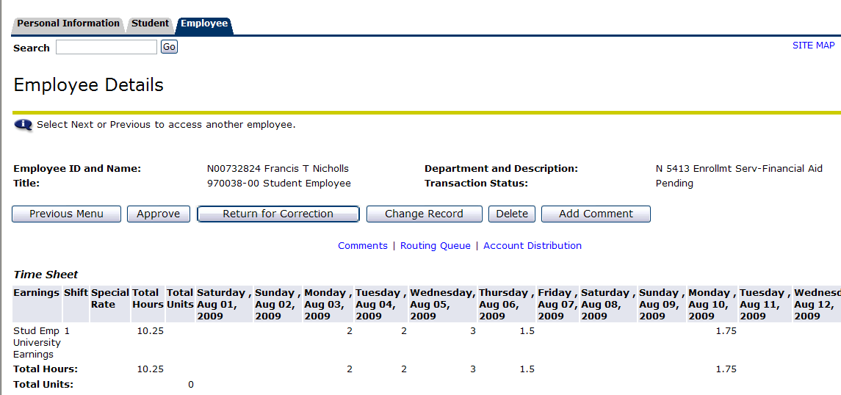

APPROVING A TIME SHEET
The Student Employment Office will send a general email reminding supervisors to approve time sheets. The Student Employment Office also encourages each student employee to send an email to their supervisor once they have submitted their time sheet for approval.
Supervisors are encouraged to log on to Banner Self Service several times during a pay period to ensure student employees are entering time.
- Select ‘Approve’.
- The message ‘Time transaction successfully approved’ will display.
Note: If a time sheet was approved by mistake, please contact Cathy Arcement (cathy.arcement@nicholls.edu) to have the time sheet returned to you.

RETURN TIME
If you have approved a student employee’s time sheet and before the Student Employee Office begins the payroll process, you may have the time sheet returned to you to make corrections. The ‘Return Time’ button will appear on the Employee Details page once you have approved an employee’s time sheet.

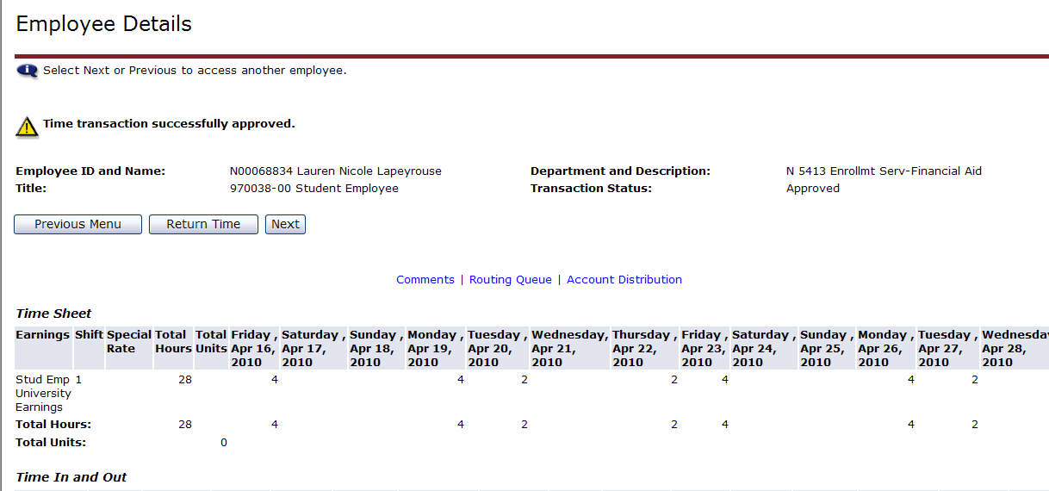

- Select ‘Return Time’ on the Employee Details page.
- Make the necessary corrections to the student employee’s time sheet.
- Select ‘Approve’.
- The message ‘Time transaction successfully approved’ will display.

CREATING A PROXY
By creating a proxy you are giving someone else in the department permission to view time sheets for your student employees and approve time. If you are sick or out of the office, the proxy could approve time.

- Select ‘Proxy Set Up’ on the Time Reporting Selection page.
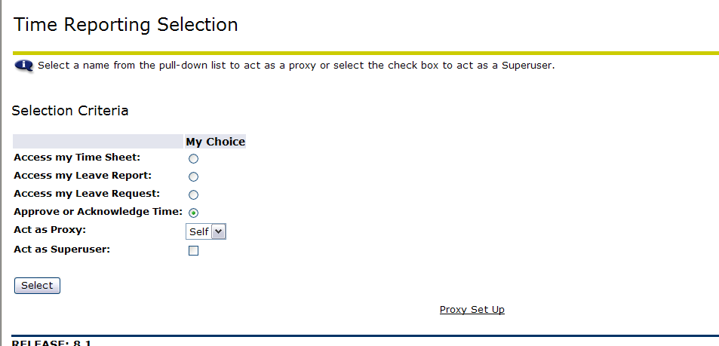
- Select from the drop down list the name of the individual who will be the proxy.
  - If the individual’s name does not appear in the list, email Rachel Babin (rachel.babin@nicholls.edu) the name of the person who you will set up as a proxy. Security will need to be set up before you can select them as a proxy.
  - Rachel will email you when you can set the person up as a proxy.
- Select the box next to the individual’s name and under ‘Add’.
- Select ‘Save’. 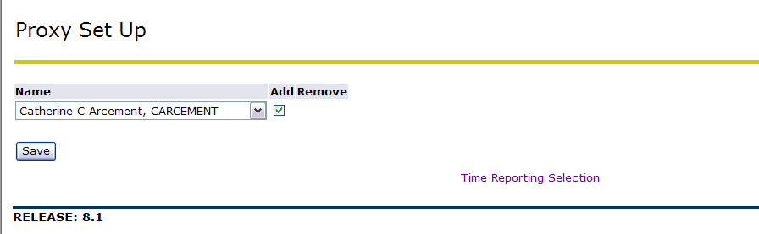
Check ‘Add’

LOGGING OUT
Select Exit in the upper right corner of the screen.

